12th November 2021

YOKOHAMA and Boeing Renew Contract for Supply of Potable Water Tanks

YOKOHAMA announced today that it has renewed its contract with The Boeing Company for the continued supply of potable water tanks used in Boeing 737, 767 and 777 airplanes.

YOKOHAMA has been supplying potable water tanks for Boeing commercial airplanes for more than 40 years since 1980. The Company also is supplying potable water tanks for Boeing’s new 777X airplanes.

Better known as one of the world's leading automotive tyre makers, YOKOHAMA also is a manufacturer of aircraft fixtures and components. Its aerospace division manufactures and sells a wide range of products, including potable water tanks, fuel tanks, thermal insulation materials, lightweight composite materials, acoustic materials, and honeycomb structures, all based on YOKOHAMA’s proprietary resin, metals, and composite material technologies developed over the years.

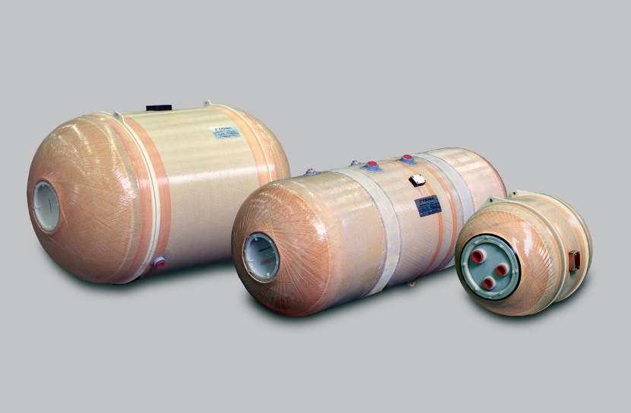
Potable Water Tanks

