7th March 2022

YOKOHAMA adds 20- & 21-inch tyres to its ADVAN Sport V107 tyres supplied for leading German automotive manufacturer’s premium cars

YOKOHAMA announced today that it has begun delivering 20- and 21-inch ADVAN Sport V107 tyres to BMW M GmbH for use on the automaker’s M3 and M4 high-performance sports models. YOKOHAMA is supplying 285/30ZR20 (99Y) size front tyres and 295/25ZR21 (96Y) rear tyres. The two newly supplied sizes differ from the 18- and 19-inch ADVAN Sport V107 tyres that YOKOHAMA has been supplying as OE for the same models since November 2020.
*For use on both models as after-parts tyres.

The “ADVAN Sport V107” is a high-performance tyre in YOKOHAMA’s global flagship ADVAN brand. The newly supplied tyres were jointly developed with BMW M and feature a specially developed compound and a tread pattern with the groove area adjusted to achieve superior dry performance and wear resistance. The tyres also have received the EU labelling system’s highest "A" grade for wet performance. The application of YOKOHAMA’s proprietary mound profile technology, which evenly distributes surface contact pressure, also contributes to the tyres’ enhanced dry performance and wear resistance. In addition, the tyres’ carcass material, which forms the tyre’s skeleton, includes a specialized material that helps deliver the excellent steering stability that is essential for high-power premium cars. Now, as one of the select few tyre makers that supply tyres for BMW M models, YOKOHAMA is delivering the tyres to BMW Group Plant Munich and Dingolfing. The tyre’s sidewall bears the German automaker’s star mark indicating its recognition of the tyre maker’s technology, quality, and reliability.

Under YOKOHAMA's current medium-term management plan, Yokohama Transformation 2023 (YX2023), the consumer tyre business aims to maximize the sales ratios of high-value-added YOKOHAMA tyres, namely the global flagship ADVAN brand, the GEOLANDAR brand of tyres for SUVs and pick-up trucks, and various winter tyres. One of the key initiatives being implemented under this strategy is the expansion of ADVAN and GEOLANDAR tyres as original equipment on new cars.

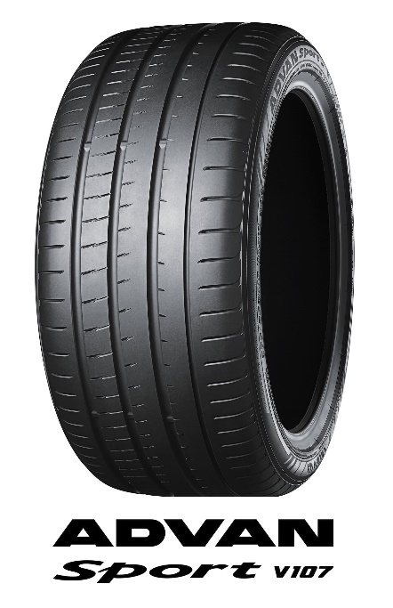
*Tyre shown in photo differs in size from those installed on the BMW M M3/M4.

