7th July 2023

YOKOHAMA´s tyre sales subsidiary and hose manufacturing and sales subsidiary in Thailand receive supplier awards from Isuzu Motors Co., (Thailand) Ltd.

YOKOHAMA announced today that Yokohama Tire Sales (Thailand) Co., Ltd. (YTST) and Yokohama Rubber (Thailand) Co., Ltd. (YRTC), which manufactures and sells hoses, were recipients of the “IMCT QD Score 100 Points 3Y” award presented by Isuzu Motors Co., (Thailand) Ltd. (IMCT), an Isuzu Motors Limited subsidiary. The awards were presented at a ceremony held by IMCT on 31st May.

“IMCT QD Score 100 Points 3Y” is awarded to IMCT suppliers who for three consecutive years have received the “Supplier Evaluation Score Both Quality & Delivery 100 Points” from IMCT’s system for scoring the performance of suppliers, with 100 points awarded to suppliers whose product quality and logistics management have not generated any problems. The award is evidence of IMCT’s high evaluation of the quality of products received from YTST and YRTC and the two companies’ supply capabilities during the past three years, from 2020 to 2022. In addition to these awards from IMCT, the two Yokohama Rubber subsidiaries in Thailand have received many supplier awards from other local car manufacturers in recent years.

Established in 2008, YTST sells YOKOHAMA’s global flagship brand ADVAN tyres, the GEOLANDAR brand of tyres for SUVs and pick-up trucks, and YOKOHAMA tyres for trucks and buses. YRTC, established in 1996, manufactures and sells automotive hose assemblies, and hydraulic hose assemblies for construction machinery. YTST supplies GEOLANDAR tyres to IMCT, and YRTC supplies IMCT with hydraulic power steering hose assemblies for automobiles.

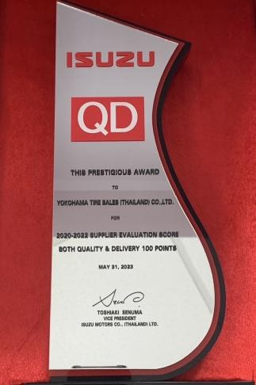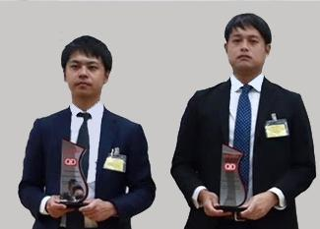
Award trophy
YTST and YRTC employees with their award trophies

Image of the compound used in ADVAN Sport EV tyres
Image of SILENTFOAM polyurethane foam attached to the tyre’s inside surface (blue coloring is for imaging purpose only)

