30th March 2023

YOKOHAMA’s Singapore subsidiary donates some 200kg of clothing and other items to Indonesian local community

YOKOHAMA announced today that its subsidiary in Singapore, Yokohama Rubber Singapore Pte. Ltd. (YRS), participated in an initiative that donated some 200kg of clothing and other items to 92 households in a local community located in Sibolga, a city in the Indonesian province of North Sumatra. The donation was made in December as part of a joint effort with Rubber Services Singapore 1877 (RSS1877), a supplier of natural rubber. This was the first time for YRS to participate in this initiative.

The donation was part of an initiative aimed at improving living conditions in a Sibolga community located in a natural rubber producing area. YRS and RSS1877 staff collected used and unused clothing, curtains, and other household items and donated them to local residents. This initiative helped raise awareness of the circular economy among staff and local residents and strengthened ties with the local community.

A founding member of the Global Platform for Sustainable Natural Rubber (GPSNR), YOKOHAMA revised its “Procurement Policy for Sustainable Natural Rubber" in 2021 and is strengthening its collaboration with GPSNR activities. YOKOHAMA’s Procurement Policy is aligned with the GPSNR's policy framework component of “Commitment to Community Livelihoods” and aims to achieve “Developing with the local community.” In addition to continuing to hold events and activities in support of natural rubber farmers and suppliers in Indonesia and Thailand, YOKOHAMA is promoting activities targeted at realizing the sustainability of natural rubber, including more widespread use of agroforestry, which also will help natural rubber farmers secure more stable income.

Yokohama Transformation 2023 (YX2023), YOKOHAMA’s medium-term management plan for fiscal years 2021–2023, includes sustainability initiatives that are based on the concept of “Caring for the Future.” YOKOHAMA believes that conducting business activities aligned with its sustainability initiatives will help resolve social issues and lead to the continued increase of its corporate value.

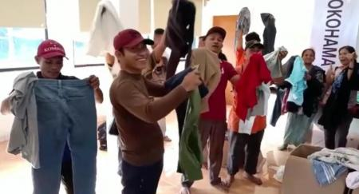
Local residents receiving donated clothing

