23rd October 2023

YOKOHAMA´s US subsidiary to supply the control tyre for the 2024 Porsche Sprint Challenge North America and USA West by Yokohama

YOKOHAMA announced today that its US subsidiary Yokohama Tire Corporation (YTC) will supply its ADVAN racing tyres as the control tyre for the Porsche Sprint Challenge North America and USA West by Yokohama* race series in the United States. YTC will supply YOKOHAMA’s ADVAN A005 tyres for dry conditions and ADVAN A006 tyres for wet conditions.
* A unified name for two related race series, the Porsche Sprint Challenge North America and Porsche Sprint Challenge USA West

Porsche Sprint Challenge North America and USA West by Yokohama race series are held for semi-professional drivers as a step-up category to the Porsche Carrera Cup races, which are widely considered to be the world’s fastest one-make races. Drivers compete in several different Porsche racing car classes, including the 911 GT3 Cup (type 992), 911 GT3 Cup (type 991 II), and 718 Cayman GT4 RS Clubsport, all of which have somewhat different specifications. The 2024 season, which begins in March, will include Porsche Sprint Challenge North America races with seven track locations and Porsche Sprint Challenge USA West races with six track locations.

Under YOKOHAMA’s three-year (2021–2023) medium-term management plan, Yokohama Transformation 2023 (YX2023), the consumer tyre business aims to maximize the sales ratios of high-value-added YOKOHAMA tyres, namely the global flagship ADVAN brand, the GEOLANDAR brand of tyres for SUVs and pick-up trucks, and various winter tyres. YX2023 also positions participation in motorsports activities as crucial to the company’s effort to develop new tyre technologies that will further strengthen the ADVAN and GEOLANDAR brands. YOKOHAMA therefore is again participating in a wide variety of motorsports events in Japan and around the globe, from top-category to grassroots events.

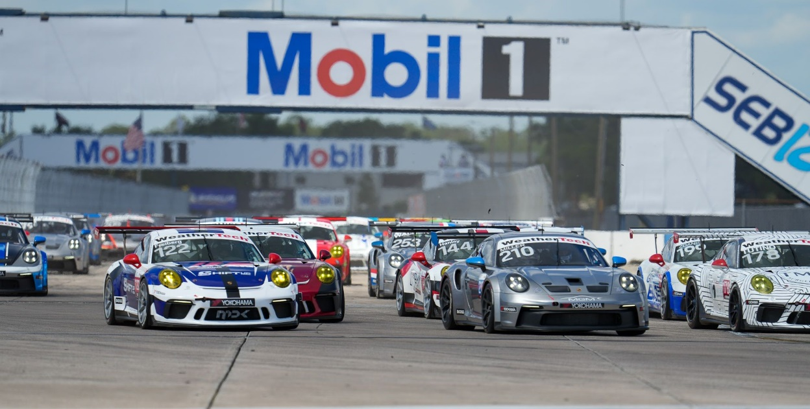
911 GT3 Cup cars competing in the Porsche Sprint Challenge North America by Yokohama

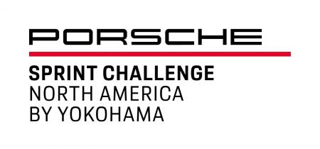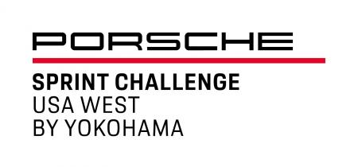
Porsche Sprint Challenge USA West by Yokohama logo
Porsche Sprint Challenge North America by Yokohama logo

