21st March 2024
YOKOHAMA Winter Drive Experience 2024
In the first week of March, YOKOHAMA invited customers from all over Europe to its Winter tyre test facility, the YOKOHAMA Test Centre of Sweden, to experience the performance of the products which the tyre dealers sell every day.
YOKOHAMA presented its existing range of winter tyres including the BluEarth*Winter V906, the iceGUARD stud iG65, the studless iceGUARD iG53 as well as the iceGUARD studless G075 for SUVs. The GEOLANDAR CV 4S G061, YOKOHAMA´s all-season tyre for crossover SUVs and pick-up trucks, was also available for testing in various stations.
As a premiere, the GEOLANDAR A/T4 G018, which will be launched to the markets later this spring, was presented for the first time to the participants. The GEOLANDAR A/T4 is the new all-terrain / all-season product for SUVs, 4x4s and pick-ups. The tyre features an aggressive block pattern and 2-in-1 dual side blocks and is designed to offer off-road traction and anti-cut and chipping benefits.
Both GEOLANDAR CV 4S G061 and A/T4 G018 have received the M+S (mud & snow) designation, which indicates they will deliver excellent performance in a sudden snowfall. Beside this, they have also obtained the Three-Peak Mountain Snowflake Symbol*, applied to tyres that meet international standards for tyres to be used in severe snow.
*The Three-Peak Mountain Snowflake Symbol is a mark certifying winter tyres for use in Europe.
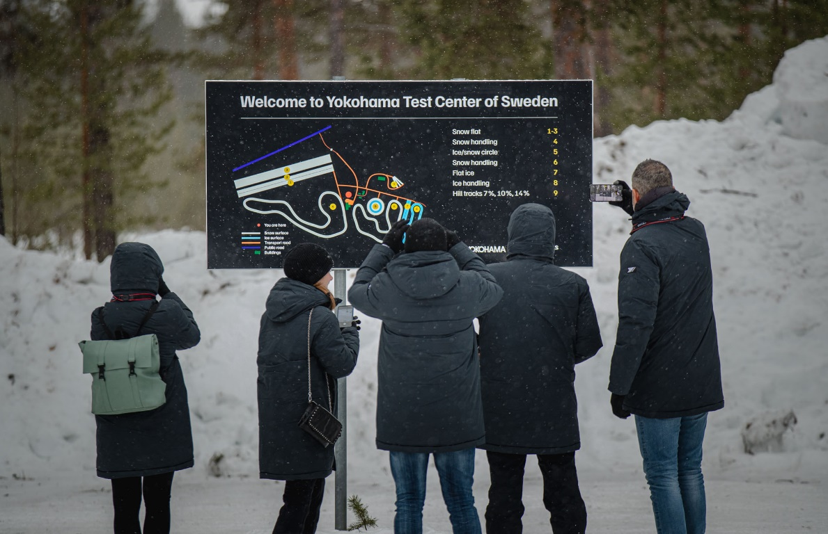
Participants at the YOKOHAMA Test Centre of Sweden
YOKOHAMA Winter Drive Experience
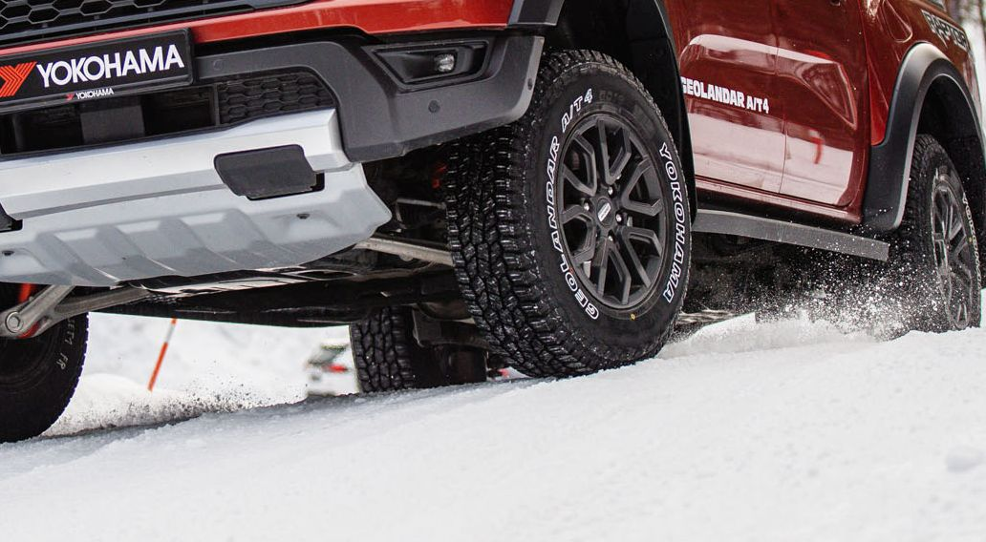
Car equipped with the new GEOLANDAR A/T4 G018

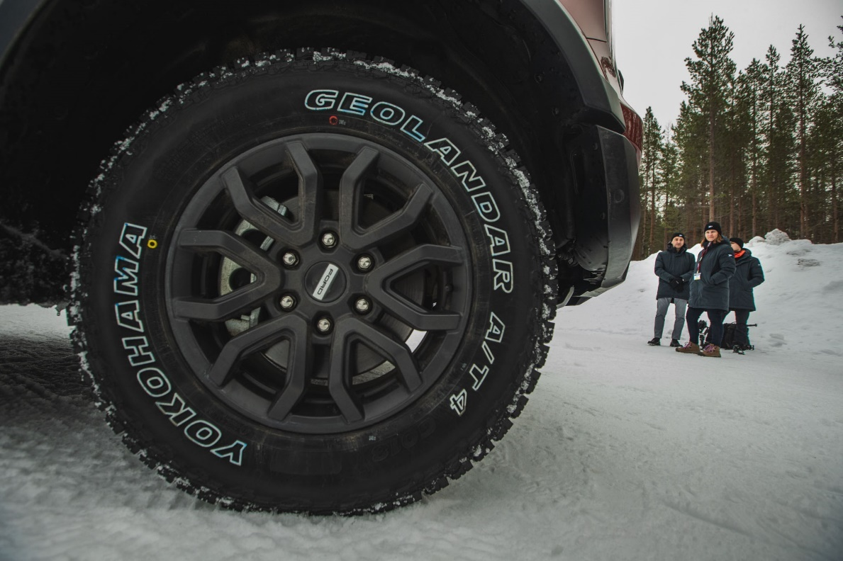
GEOLANDAR A/T4 G018

