20th March 2023

YOKOHAMA Motorsports Activity Plan in 2023

YOKOHAMA today announced its motorsports activity plan for 2023. The consumer tyre business in the company’s current medium-term management plan, Yokohama Transformation 2023 (YX2023), aims to maximize the sales ratios of high-value-added YOKOHAMA tyre brands, namely the global flagship ADVAN brand, the GEOLANDAR brand of tyres for SUVs and pick-up trucks, and various winter tyres. YX2023 also positions participation in motorsports activities as crucial to the company’s effort to develop new tyre technologies that will further strengthen the ADVAN and GEOLANDAR brands. YOKOHAMA therefore will supply tyres to a wide variety of motorsports events in Japan and around the globe, from top-category to grassroots events.

This year marks the 45 year anniversary of ADVAN, and under the theme of ADVAN CHALLENGE, which is intended to maximize sales of ADVAN tyres, we will aim to win in the top categories, such as SUPER GT, the Nürburgring 24-Hour Race, and the Pikes Peak International Hill Climb, which many strong teams participate in. In addition, we will continue to take on the challenge of achieving sustainable motorsports, such as by providing racing tyres made from renewable and recyclable materials in actual races and the development of such technologies. The dedicated production line at the Mishima plant, which produces motorsport tyres, will use 100% renewable electricity to achieve carbon-neutral production of motorsport tyres. Through these activities, we aim to increase the quality in a variety of aspects, such as our products, brands, technologies, and sales in order to maximize ADVAN.

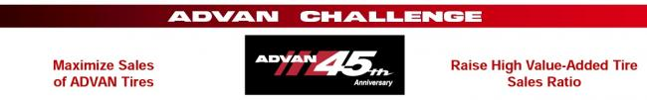

This release briefly introduces some of the main events Yokohama Rubber will be participating in this year. Also, we will post event updates and results on YOKOHAMA’s dedicated motorsports website and on our official motorsports SNS sites.

[SUPER GT GT500 Class]

-> SUPER GT
Super GT races are contested in two classes, GT500 and GT300. GT500 is dominated by works teams from major automakers while GT300 teams tend to be more varied and individualistic. While all GT500 machines must meet certain specifications, GT300 races are open to a variety of cars made in Japan and overseas. The GT300 machines can broadly be divided into three types: (1) automakers’ production cars that meet the international FIA GT3 specifications, (2) unique GTA-GT300 machines, and (3) the so- called “Mother Chassis” group of machines. Last year, KONDO RACING’s REALIZE NISSAN MECHANIC CHALLENGE GT-R won the series championship in the GT300 class. In GT500, YOKOHAMA-supported teams won five pole positions in eight races. This year, we will supply ADVAN racing tyres for two vehicles of GT500 and 16 vehicles of GT300, and aim to win GT500 and the series champion in GT300 consecutively.
[SUPER GT GT500 Class] KONDO RACING REALIZE CORPORATION ADVAN Z (2022)
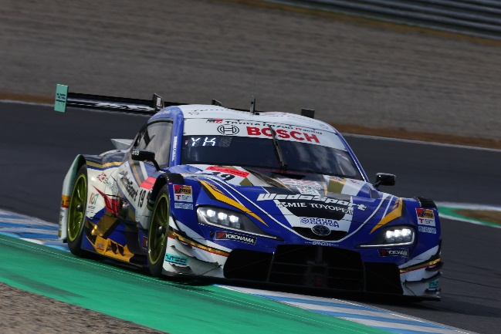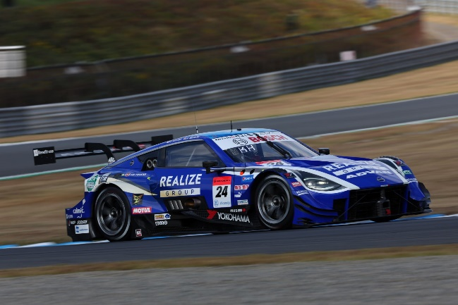
[SUPER GT GT500 Class] TGR TEAM WedsSport BANDOH WedsSport ADVAN GR Supra (2022)
[SUPER GT GT500 Class] KONDO RACING REALIZE CORPORATION ADVAN Z (2022)
GT500 class teams being supported by YOKOHAMA in 2023:
Teams | Drivers | Vehicle
TGR TEAM WedsSport BANDOH | Yuji Kunimoto  Sena Sakaguchi | WedsSport ADVAN GR Supra
KONDO RACING | Daiki Sasaki  Kohei Hirate | REALIZE CORPORATION ADVAN Z

GT300 class teams being supported by YOKOHAMA in 2023
Teams | Drivers | Vehicle
GOODSMILE RACING & TeamUKYO | Nobuteru Taniguchi  Tatsuya Kataoka | GOODSMILE HATSUNE MIKU AMG
TEAM MACH | Yusuke Tomibayashi  Takamitsu Matsui | MACHSYAKEN AIR BUSTER MC86 MACH GO
Team LeMans | Yoshiaki Katayama  Roberto Merhi | Muntan DOBOT Audi R8 LMS
PACIFIC RACING TEAM | Ryohei Sakaguchi  Liang Jiatong | TBN*
TEAM UPGARAGE | Takashi Kobayashi  Syun Koidec | UPGARAGE NSX GT3
R'Qs MOTOR SPORTS | Hisashi Wada  Masaki Jyonai | R'Qs AMG GT3
HOPPY team TSUCHIYA | Togo Suganami  Seita Nonaka | HOPPY Schatz GR Supra GT
Yogibo Racing | Yugo Iwasawa  Reimei Ito | Yogibo NSX GT3
apr | Hiroaki Nagai  Manabu Orido | apr GR86 GT
NILZZ Racing | Taiyo Ida  Yuki Tanaka | SHOKUMOU Ks Frontier GT-R
ANEST IWATA Racing with Arnage | Igor Omura Fraga  Yuga Furutani | ANEST IWATA Racing RC F GT3
KONDO RACING | Joao Paulo de Oliveira  Teppei Natori | REALIZE NISSAN MECHANIC CHALLENGE GT-R
JLOC | Kosuke Matsuura  Natsu Sakaguchi | Bamboo Airways Lamborghini GT3
JLOC | Takashi Kogure  Yuya Motojima | TBN*
Max Racing | Kimiya Sato  Atsushi Miyake | HACHI-ICHI GR Supra GT
TOMEI SPORTS | Takayuki Aoki  Atsushi Tanaka | RUNUP RIVAUX GT-R
* Yet to be named as of March 3

-> Nürburgring 24-Hour Race
YOKOHAMA will be participating in the Nürburgring 24-Hour Race (ADAC TotalEnergies 24h Nürburgring) and Nürburgring Endurance Series (NLS) by supplying ADVAN racing tyres to the three BMW M4 GT3 cars being entered by BMW’s Customer Racing team Walkenhorst Motorsport, continuing the partnership agreement that began in 2021. This year, we will aim to win the overall championship in the 24-hour race with two SP9 Pro class cars.

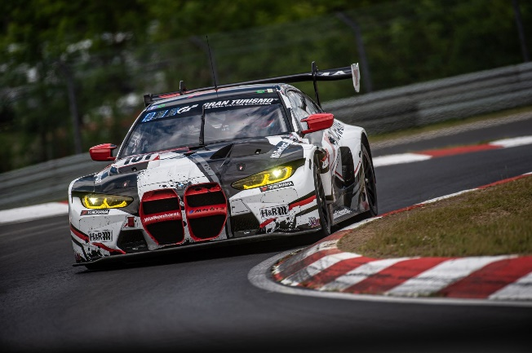
[Nürburgring 24-Hour Race] Walkenhorst Motorsport BMW M4 GT3 (2022)

-> Other GT and Touring Car Races
YOKOHAMA will continue to supply the ADVAN racing tyres for the Porsche Sprint Challenge North America by Yokohama, the RAAT Thailand Endurance International Championship, Toyota Gazoo Racing Motorsport, Honda One Make Race, and the Inter Proto Series in Japan.

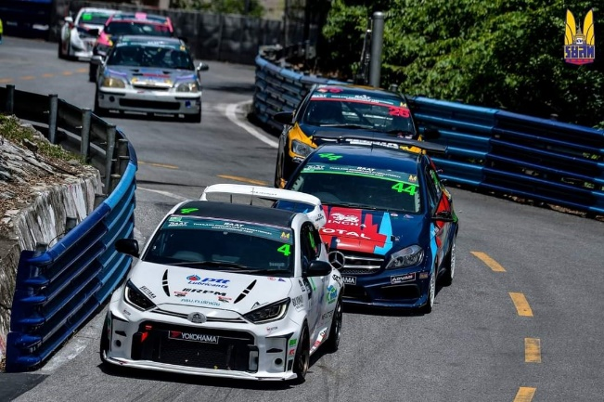
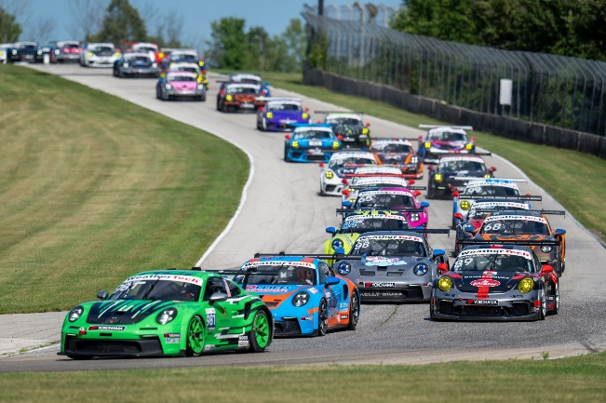
[Porsche Sprint Challenge North America by Yokohama] Porsche 911 GT3 Cup (2022)
[RAAT Thailand Endurance International Championship] (2022)

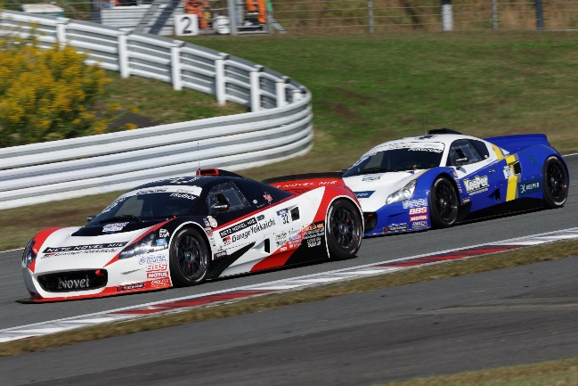
[Inter Proto Series] (2022)

Formula Races
-> Japanese SUPER FORMULA Championship
YOKOHAMA tyres have been the control tyres for the Japanese SUPER FORMULA Championship since 2016. This year, we will begin supplying ADVAN racing tyres, made from 33% sustainable materials, as control tyres. Racing tyres using sustainable materials are being supplied in support of SUPER FORMULA NEXT 50 project promoted by Japan Racing Promotion Inc., which runs the SUPER FORMULA series. This project is being promoted with the cooperation of various companies that share the common goal of creating a sustainable motorsports industry by responding to changes in the environment surrounding the automobile and motorsports industries, including the promotion of SDGs and carbon neutrality. From the perspective of promoting the development of circular economy tyres, YOKOHAMA aims to develop racing tyres that include sustainable materials without compromising driving performance. YOKOHAMA tested its tyres as part of the trial runs for next-generation formula cars that were held before and after each SUPER FORMULA race during the 2022 season. The company will continue its efforts to develop tyres with higher sustainable material content in 2023 and coming years.

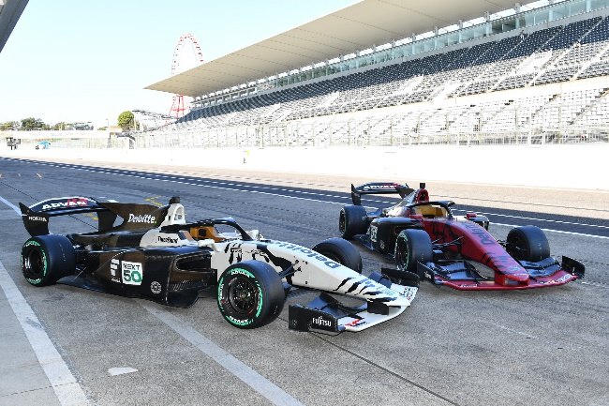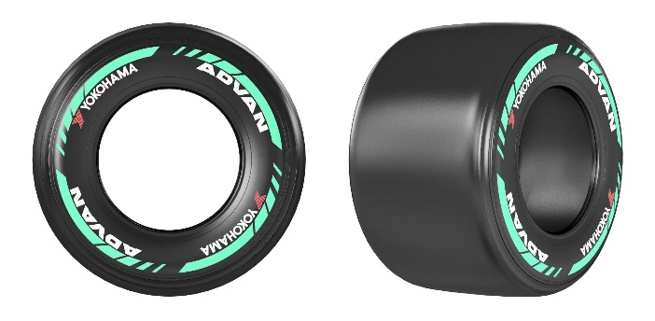
New model SF23
ADVAN racing tyres made from sustainable materials

Rally and Rally Cross
-> Japan Rally Championship
YOKOHAMA will equip teams participating in several classes with high-performance tyres that can propel them safely to a championship, including JN1 in the highest class, which are subject to new regulations starting from this year. We will be supplying ADVAN A051T, ADVAN A08B and ADVAN A052 for use on tarmac and ADVAN A053 for use on gravel.
Toshihiro Arai/Naoya Tanaka Fuji Subaru AMS WRX STI (2022)
Fumio Nutahara/Shungo Azuma ADVAN KYB KTMS GR YARIS (2022)
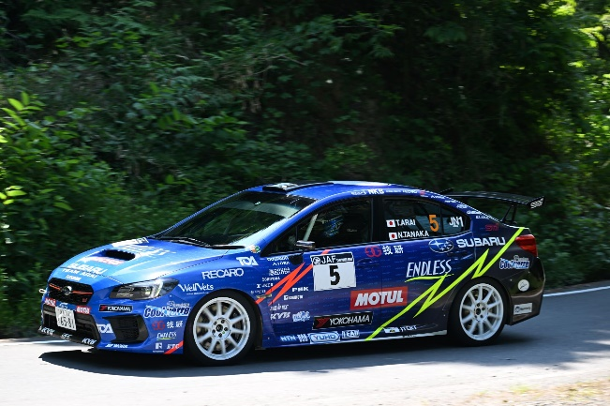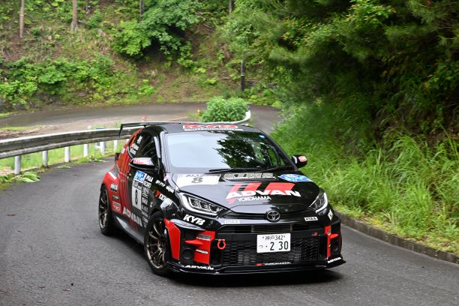

Drivers  Co-Drivers | Teams | Vehicle
Toshihiro Arai  Takahiro Yasui | SUBARU RALLY CHALLENGE ARAI | SUBARU WRX Rally
Fumio Nutahara  Shungo Azuma | NUTAHARA Rally Team | ADVAN KYB KTMS GR YARIS

-> Nitro Rallycross
YOKOHAMA also will be supplying ADVAN rallycross tyres to teams participating in the Nitro Rallycross (NRX), which was launched in 2021 in North America and is expanding into the Middle East this year. YOKOHAMA will provide its ADVAN rallycross tyres as control tyres for the vehicles in EV category in addition to internal combustion engine vehicles.
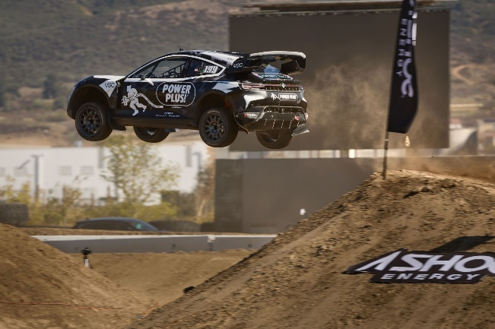
[Nitro Rallycross] Participating vehicle (2022)

-> Other Rallies
YOKOHAMA will supply ADVAN rally tyres to the Subaru Rally Team USA, which participates in the ARA (American Rally Association) Rally in the United States, and the Toyota Team Thailand, which participates in the FIA Asia-Pacific Rally Championship 2023 Round 2 “South India Rally”.
[ARA Rally] Subaru Rally Team USA (2022)
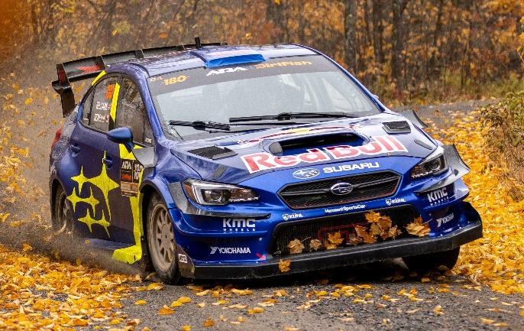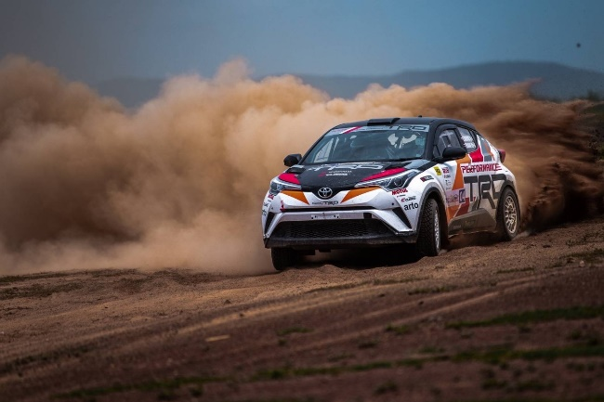
[FIA Asia-Pacific Rally Championship 2023 Round 2 “South India Rally”] Toyota Team Thailand (2022)

Speed Competitions
-> Japanese Gymkhana Championship
Gymkhana are time-based competitions in which cars run one-by-one over a paved course with obstacles. In 2023, we will be supplying our ADVAN NEOVA AD09, and ADVAN A050 high-performance tyres to teams aiming to capture series championships in several Gymkhana classes.
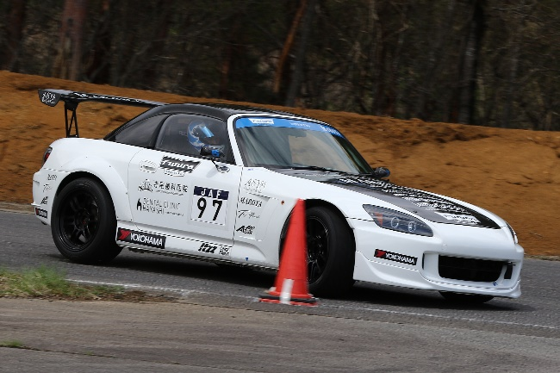
[2022 Japanese Gymkhana Championship] Maroya Trailer S2000 Asya

->Japanese Dirt Trial Championship
Dirt trial competitions are time-based competitions in which cars run one-by-one over an unpaved course. YOKOHAMA is supporting teams vying for the series championship in several classes with a line-up of tyres that can deliver superior performance on various surfaces, starting with ADVAN A053 tyres and then ADVAN A031 tyres for softer surfaces and ADVAN A036 tyres for ultra-hard surfaces.

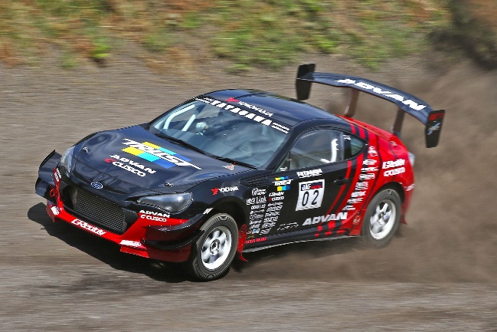
[2022 Japanese Dirt Trial Championship] TRUST ADVAN CUSCO BRZ

Grassroots Motorsports
YOKOHAMA will supply tyres for the Toyota GAZOO Racing Rally Challenge 2023, N-ONE OWNER’S CUP, which is a one-design race by HONDA N-ONE, and races held at circuits in various locations.
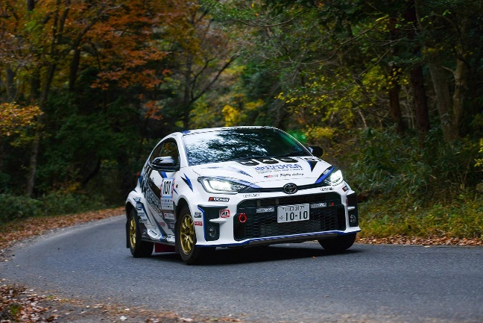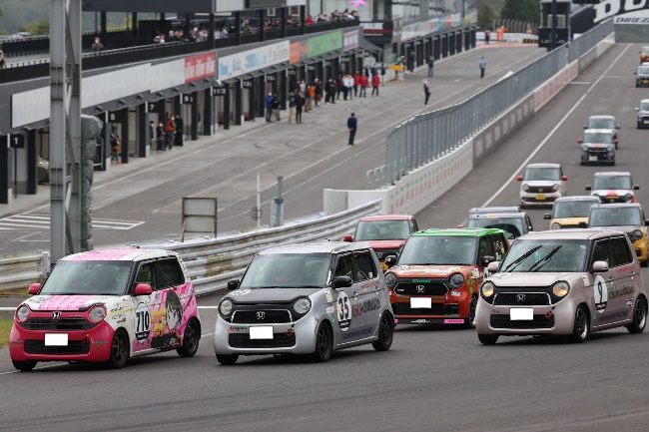
[N-ONE OWNER'S CUP] (2022)
[TOYOTA GAZOO Racing Rally Challenge] Aki HATANO/Teru Ogura HAL GR Yaris-ORC (2022)

Off-road Races
-> Asia Cross Country Rally
YOKOHAMA will supply GEOLANDAR M/T G003 tyres to the teams participating in the Asia Cross Country Rally 2023, the largest cross country rally in Asia. Last year, the vehicles equipped with these tyres won the overall championship and also demonstrated excellent performance by taking the third, fourth and fifth places of five overall prizes.
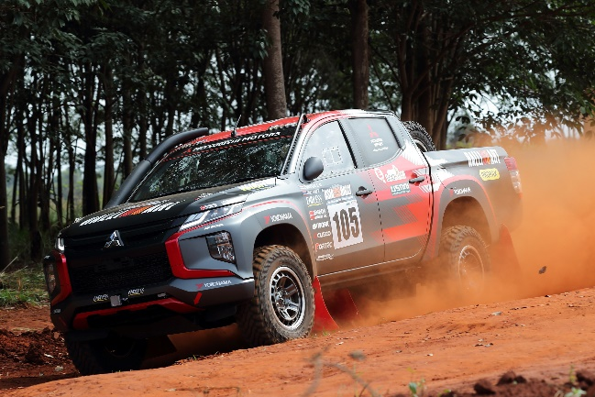
GEOLANDAR-equipped vehicle, which won the overall championship in the Asia Cross Country Rally 2022

->Other Off-road Races
YOKOHAMA will be supplying our GEOLANDAR brand tyres for SUVs and pick-up trucks to teams competing in off-road races, such as King of the Hammers and SCORE series in North America.
In King of the Hammers held in North America in February this year, the GEOLANDAR-equipped vehicle won first place in the 4900 Can-Am UTV race in addition to winning its class. Last year, the GEOLANDAR-equipped vehicle participated in a number of races, winning the Pro UTV Open class at the 35th SCORE SAN FELIPE 250 in Mexico and winning UTV N/A Pro class of 2022 Method Race Wheels “Casey Folks” Vegas to Reno, which is one of the Best In The Desert 2022 series races, the largest off-road races in North America.

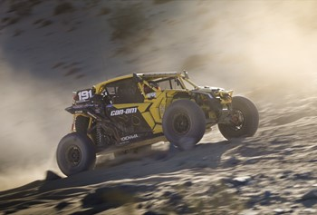
Kyle Chaney’s UTV on its way to victory in the 4900 Can-Am UTV race at 2023 King of the Hammers

Other Events
-> Hill Climbs
This year, YOKOHAMA will again participate in the Pikes Peak International Hill Climb in Colorado, USA, where an ADVAN racing tyre-equipped vehicle won the overall championship last year. This year, we will be providing EV vehicles participating in the exhibition class with ADVAN tyres made from biomass-derived butadiene rubber again, while supplying our tyres to many teams participating in other classes, in order to win consecutive championships. In addition, we will continue our role as provider of the control tyre for the Porsche Pikes Peak Trophy by YOKOHAMA, a hill climb that pits drivers of Porsche Cayman GT4 Clubsport vehicles against each other.

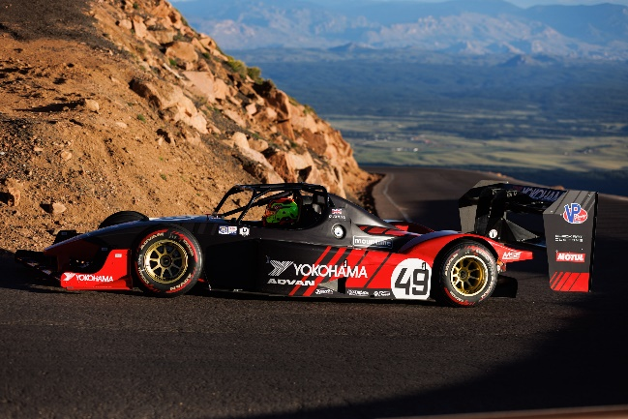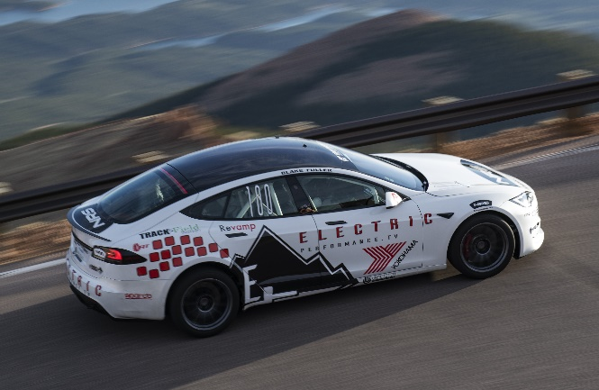
ADVAN A052-equipped vehicle, which is made from biomass materials, at Pikes Peak International Hill Climb (2022)
ADVAN-equipped vehicle, which won the overall championship at Pikes Peak International Hill Climb (2022)

Yokohama Rubber Motorsports Website (English)
https://www.y-yokohama.com/cp/global/motorsports/

Official SNS websites
Facebook: https://www.facebook.com/YRCmotorsports/
Twitter: https://twitter.com/yokohama_sport
Instagram: https://www.instagram.com/yokohama_motorsports/

