31st March 2022

YOKOHAMA Motorsports Activity Plan in 2022

YOKOHAMA today announced its motorsports activity plan in 2022. The consumer tyre strategy in the Company’s current medium-term management plan, Yokohama Transformation 2023 (YX2023), aims to maximize the sales ratios of high-value-added YOKOHAMA tyre brands, namely the global flagship ADVAN brand, the GEOLANDAR brand of tyres for SUVs and pick-up trucks, and various winter tyres. YX2023 also positions participation in motorsports activities as crucial to the Company’s effort to develop new tyre technologies that will further strengthen the ADVAN and GEOLANDAR brands. YOKOHAMA therefore will again participate in a wide variety of motorsports events in Japan and around the globe, from top-category to grassroots events. In addition, as part of its effort to support realization of a sustainable society, YOKOHAMA will begin using its participation in races that provide extremely severe test conditions to further its development of tyres that use renewable and recyclable materials.

We will post event updates and results on YOKOHAMA’s dedicated motorsports website and on our official motorsports SNS websites.

GT/Touring Car Races
■ SUPER GT
Super GT races are contested in two classes, GT500 and GT300. GT500 is dominated by works teams from major automakers while GT300 teams tend to be more varied and individualistic. While all GT500 machines must meet certain specifications, GT300 races are open to a variety of cars made in Japan and overseas. The GT300 machines can broadly be divided into three types: (1) automakers’ production cars that meet the international FIA GT3 specifications, (2) unique JAF-GT machines, and (3) the so-called “Mother Chassis" group of machines. YOKOHAMA-supported teams participated in all eight GT500 races in 2021, reaching the podium on three occasions. In 2022, we will be supporting two teams in their efforts to win the GT500 class championship. In the GT300 class, we are supporting 15 teams
and look forward to reclaiming the series championship won in 2020.

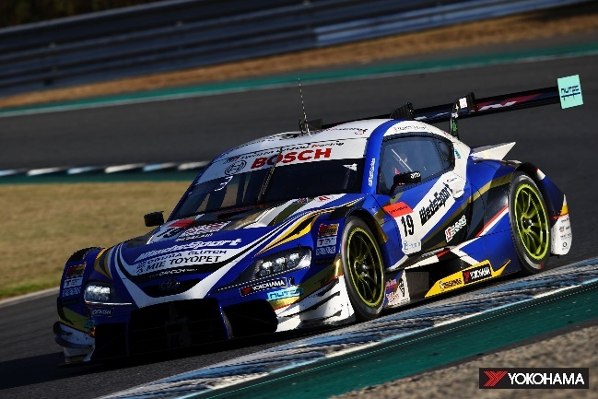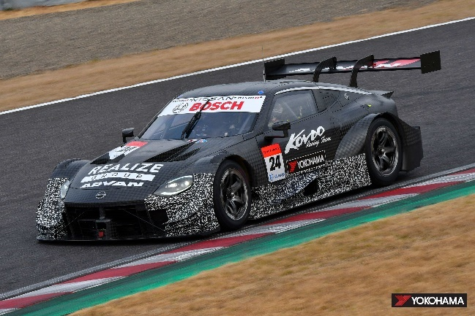
TGR TEAM WedsSport BANDOH’s WedsSport ADVAN KONDO RACING’s REALIZE CORPORATION ADVAN Z
GR Supra is competing in the GT500 class is competing in the GT500 class

GT500 class teams being supported by Yokohama Rubber in 2022
Teams | Drivers | Vehicle
TGR TEAM WedsSport BANDOH | Yuji Kunimoto  Sena Sakaguchi | WedsSport ADVAN GR Supra
KONDO RACING | Daiki Sasaki  Kohei Hirate | REALIZE CORPORATION ADVAN Z

GT300 class teams being supported by Yokohama Rubber in 2022
Teams | Drivers | Vehicle
GOODSMILE RACING & TeamUKYO | Nobuteru Taniguchi  Tatsuya Kataoka | GOODSMILE HATSUNE MIKU AMG
TEAM MACH | TBN* | TBN*
MOTOYAMA Racing w/ Team LeMans | Satoshi Motoyama  Yoshiaki Katayama | Team LeMans Audi R8 LMS
PACIFIC CARGUY Racing | Takeshi Kimura  Kei Cozzolino | PACIFIC Hololive NAC Ferrari
TEAM UPGARAGE | Takashi Kobayashi  Kakunoshin Ohta | UPGARAGE NSX GT3
R'Qs MOTOR SPORTS | Hisashi Wada  Masaki Jyonai | R'Qs AMG GT3
HOPPY team TSUCHIYA | Takamitsu Matsui  Seita Nonaka | HOPPY GR Supra GT
Apr | Hiroaki Nagai  Manabu Orido | apr GR86 GT
NILZZ Racing | Taiyo Iida  TBN* | TBN*
Arnage Racing | Masaki Kano  Ryohei Sakaguchi | Arnage MC86
KONDO Racing | Kiyoto Fujinami  Joao Paulo de  Oliveira | REALIZE NISSAN MECHANIC  CHALLENGE GT-R
JLOC | Kosuke Matsuura  Natsu Sakaguchi | TBN*
JLOC | Takashi Kogure  Yuya Motojima | TBN*
Max Racing | Kimiya Sato  Atsushi Miyake | HACHI-ICHI GR Supra GT
TOMEI SPORTS | Takayuki Aoki  Atsushi Tanaka | RUNUP RIVAUX GT-R

■ Nürburgring Endurance Races
YOKOHAMA will be participating in this year’s 50th Nürburgring 24-Hour Endurance Race (ADAC TOTAL 24h-Rennen) and the 2022 Nürburgring Endurance Series (NLS) by supporting the three BMW M4 GT3 cars being entered by BMW’s customer racing team Walkenhorst Motorsport, continuing the partnership agreement that began in 2021. Racing on YOKOHAMA’s ADVAN racing tyres, Walkenhorst Motorsport was the overall winner at the 44th RCM DMV Grenzlandrennen, the sixth round of the NLS. We will once again be supplying the team’s three cars with ADVAN A005 tyres for dry conditions and ADVAN A006 tyres for use on wet tracks.

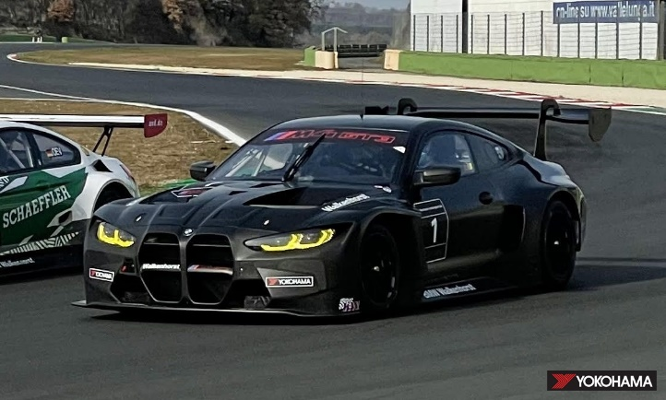
A Walkenhorst Motorsport BMW M4 GT3 on a test run

■ TCR Regional Series
YOKOHAMA will again supply ADVAN racing tyres as the control tyre for TCR regional series held around the world, including TCR Scandinavia. The tyres being supplied are ADVAN A005 for dry tracks and ADVAN A006 for wet tracks.

■ Other GT and Touring Car Races
In addition to the above races, YOKOHAMA will continue in its role as supplier of the control tyres for the Porsche Sprint Challenge North America by YOKOHAMA and the Yokohama Drivers Cup USA, providing our ADVAN racing tyres to race participants for a second straight year. We will also continue to supply our ADVAN racing tyres for use in the Inter Proto Series in Japan.

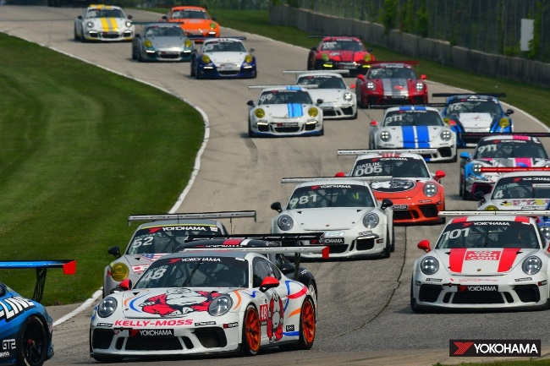
Porsche 911 GT3 Cup cars racing in the Porsche Sprint Challenge North America by YOKOHAMA

Formula Races
■ Japanese SUPER FORMULA Championship
YOKOHAMA tyres have been the control tyres or the Japanese SUPER FORMULA Championship since 2016. In 2022, we will again supply ADVAN A005 tyres for use on dry tracks and ADVAN A006 tyres for use on wet tracks. From 2023, we plan to provide the SUPER FORMULA series with racing tyres made from sustainable materials, including a naturally derived compounding agent and recyclable raw materials. Toward that end, we will be testing tyres now under development in trial runs before
and after each of this year’s seven SUPER FORMULA series races.

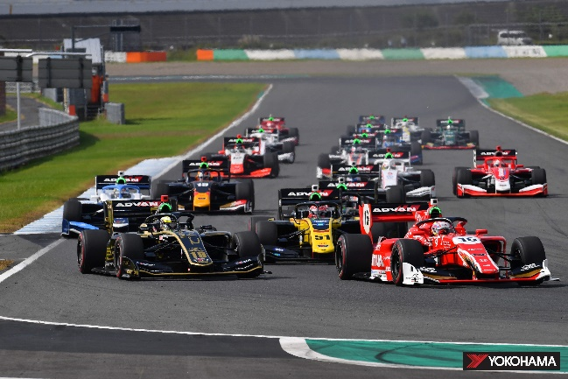
Japanese SUPER FORMULA in 2021 Championship
■ Japanese SUPER FORMULA LIGHTS Championship
The driver who wins the SUPER FORMULA LIGHTS series championship will qualify to participate in the season-ending SUPER FORMULA rookie test. Accordingly, the SUPER FORMULA LIGHTS series has become known as the “Gateway to becoming a top driver,” and we are proud to once again support drivers’ efforts by supplying ADVAN A005 tyres for use on
dry tracks and the ADVAN A006 for races on wet tracks.

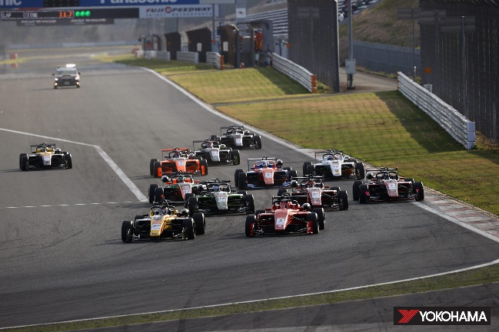
Japanese SUPER FORMULA LIGHTS in 2021 Championship

Rally
■ Japan Rally Championship
YOKOHAMA will equip teams participating in several classes with high-performance tyres that can propel them safely to a championship. Again, this year, we will be supplying ADVAN A08B and ADVAN A052 for use on tarmac and ADVAN A053 for use on gravel.

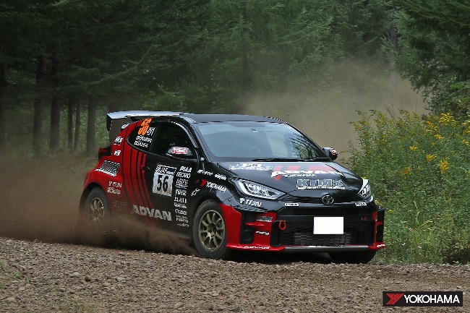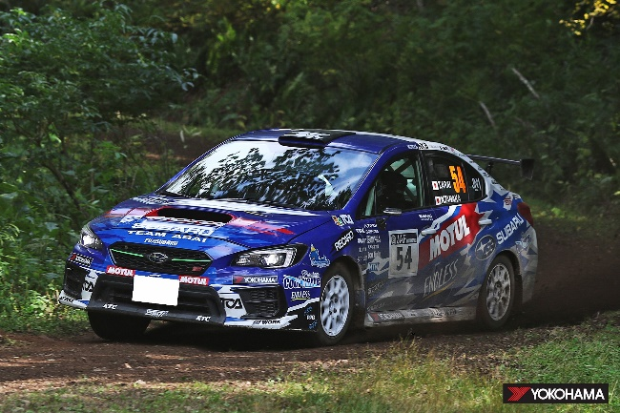
ADVAN KTMS GR YARIS driven by Fumio Nutahara Fuji Subaru AMS WRX STI driven by Toshihiro Arai
and Shungo Azuma in 2021 and Naoya Tanaka in 2021

(JN-1 class teams supported by YOKOHAMA in 2022)
Drivers  Co-Drivers | Teams | Vehicle
Fumio Nutahara  Shungo Azuma | NUTAHARA Rally Team | ADVAN KYB KTMS GR YARIS
Toshihiro Arai  Naoya Tanaka | SUBARU TEAM ARAI | Fuji Subaru AMS WRX STI

■ Other Rally and Rallycross Competitions
In 2022, we will supply ADVAN A053* tyres to the Subaru Rally Team USA participating in the American Rally Association’s ARA National Rally Championship Series in the USA. We also will be supplying ADVAN tyres to teams participating in the Nitro Rallycross (NRX), which was launched in 2021 in North America and is expanding into Europe and the Middle East this year. YOKOHAMA will provide its ADVAN tyres to 10 vehicles participating in the newly added EV category in addition to continuing its support for several teams racing conventional internal combustion engine vehicles.
* A development tyre

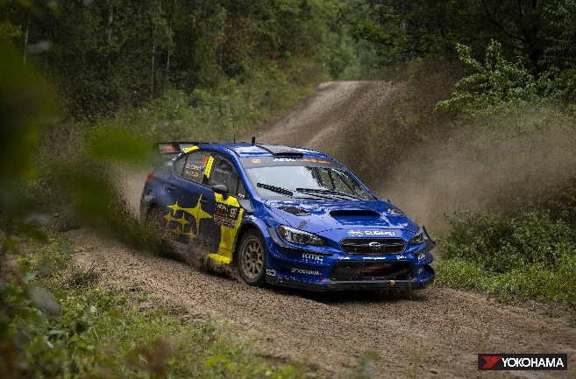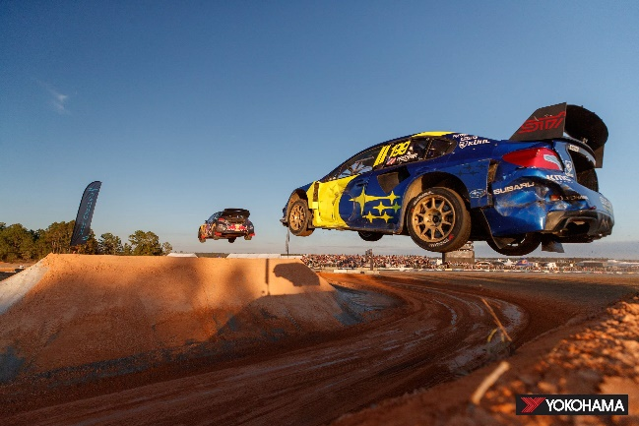
Subaru Rally Team USA driven by Travis Pastrana A typical NRX (Nitro Rallycross) scene
in the ARA Rally race

Speed Competitions
■ Japanese Gymkhana Championship
Gymkhana are time-based competitions in which cars run one-by one over a paved course with obstacles. In 2022, we again will be supplying our ADVAN A08B, ADVAN A052, and ADVAN A050 high-performance tyres to teams aiming to capture series championships in several Gymkhana classes.

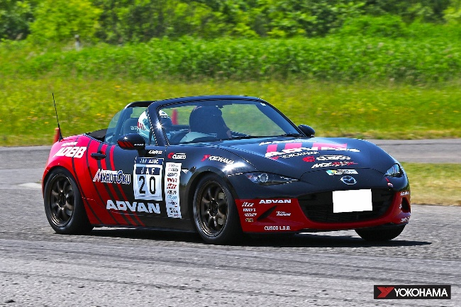
ADVAN08B Roadster driven by Kunio Saito

■ Japanese Dirt Trial Championship
Dirt trial competitions are time-based competitions in which cars run one-by-one over an unpaved course. YOKOHAMA is supporting teams vying for the series championship in several classes with a line-up of tyres that can deliver superior performance on various surfaces, starting with ADVAN A053 tyres and then ADVAN A031 tyres for softer surfaces and ADVAN A036 tyres for ultra-hard surfaces.

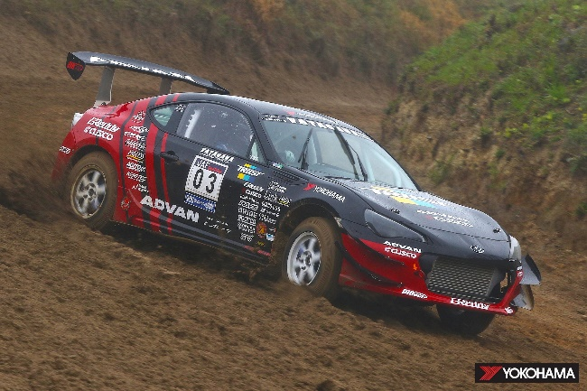
The TRUST ADVAN CUSCO BRZ driven by Toshiyuki Yatagawa

Grassroots Motorsports
We again will supply tyres for the TOYOTA GAZOO Racing Rally Challenge, HONDA’s N-ONE OWNER'S CUP, and other races open to amateur race enthusiasts at various circuits in Japan.

Off-Road Races
We will be supplying our GEOLANDAR brand tyres for SUVs and pick-up trucks to teams competing in desert races in North America, such as the Mint 400, and in Oceania, as well as cross-country races in Asia and other off-road races around the world. In 2021, GEOLANDAR-equipped machines turned in brilliant performances in several events, including a one-two finish in the 4800 class at the 2021 King Shocks Area BFE Beatdown in the USA, a first-place finish in the Pro UTV NA class at the 34th SCORE SAN FELIPE 250 in Mexico, and a first-place finish in the Trick Truck class of the 2021 King Shocks Laughlin Desert Classic, part of the Best In The Desert series held in the USA.

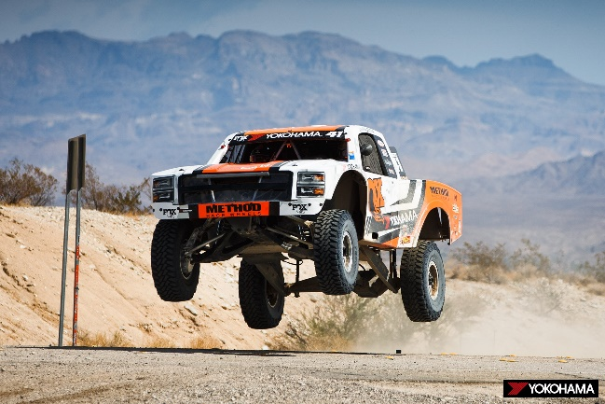
Justin Lofton’s Jimco trophy truck on its way to victory in the 2021 King Shocks Laughlin Desert Classic

Other Events
■ Hill Climbs
YOKOHAMA will again participate in the Pikes Peak International Hill Climb in Colorado, USA. This year marks the 100th running of America’s second oldest auto race. This year, we will be providing EV vehicles participating in the exhibition class with ADVAN tyres made from biomass-derived butadiene rubber, while again supplying our tyres to many teams participating in other classes. In addition, we will continue our role as provider of the control tyre for the Porsche Pikes Peak Trophy by Yokohama, a hill climb that pits drivers of Porsche Cayman GT4 Clubsport vehicles against each other. In 2021, vehicles running on YOKOHAMA tyres finished first in the Pikes Peak Open and Exhibition classes, and we look forward to a YOKOHAMA-equipped car recapturing the overall championship in 2022.

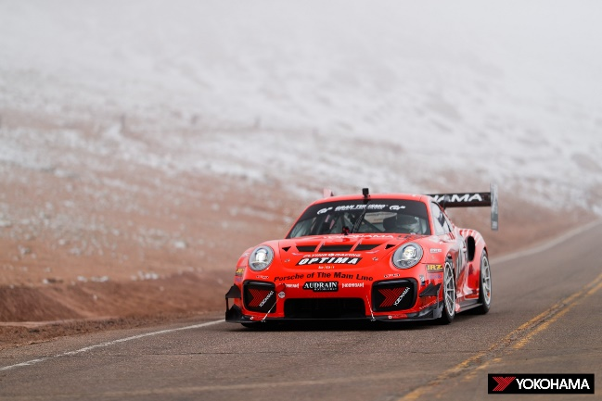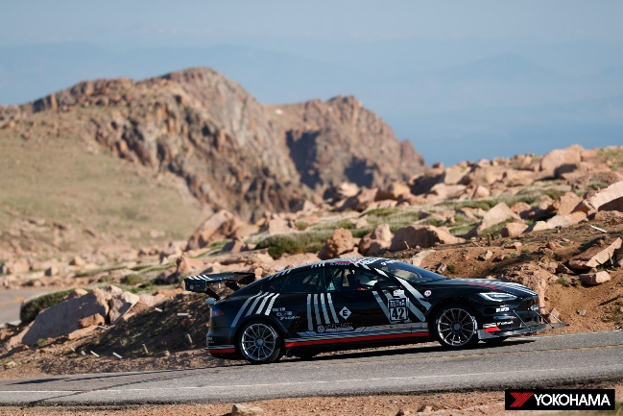
2015 Porsche BBI Turbo Cup driven by Raphael Astier 2021 Tesla Model S Plaid driven by Randy Pobst climbing to a
racing to victory in the 2021 Pikes Peak Open class first-place finish in the Exhibition class

Kart Races
We will again provide YOKOHAMA tyres to teams and drivers seeking victory in the top-level OK class of the All Japan Karting Championship, the country’s premier kart racing series. YOKOHAMA also will continue to support the FP-Junior Cadets category of the Japanese Junior Karting Championship by supplying ADVAN tyres as the control tyre. Overseas, we again will be supplying the control tyre for the Asian Karting Open Championship.

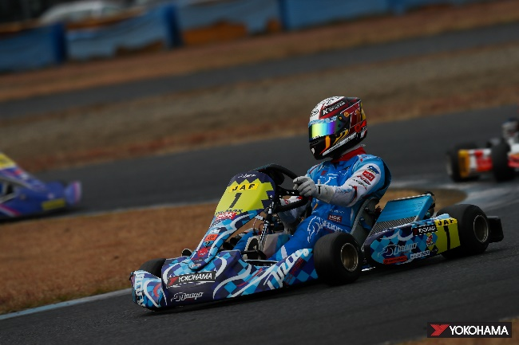
Drago Corse team member Taichi Watarai competing in the OK class of the 2021 All Japan Karting Championship

【YOKOHAMA’s motorsports website】
https://www.y-yokohama.com/cp/global/motorsports/

【Official SNS websites】
Facebook: https://www.facebook.com/YRCmotorsports/
Twitter: https://twitter.com/yokohama_sport
Instagram: https://www.instagram.com/yokohama_motorsports/

