8th February 2024

YOKOHAMA GEOLANDAR-equipped vehicles finish 1st in 3 classes at the 2024 King of the Hammers off-road race in the U.S.

YOKOHAMA is pleased to announce that vehicles equipped with its GEOLANDAR off-road tyres for SUVs and pick-up trucks finished 1st in 3 classes at this year’s King of the Hammers off-road race held in California from January 28 to February 3.

The King of the Hammers, which is the season opener for the year-long Ultra4 National Series racing tour, combines desert racing and rock crawling, and is considered the one of the toughest off-road races in the world. The winning drivers are Zach Szymik in the 4900 Can-Am Sportsman Stock UTV class, Bailey Cole in the 4600 Currie Enterprises Stock class, and Duane Garretson in the 4500 Yukon Gear and Axle Modified class. At this year’s King of the Hammers, YOKOHAMA supplied its GEOLANDAR tyres to more than 25 participating vehicles. The tyres supplied included GEOLANDAR M/T G003 mud terrain tyres and race-versions of the same, as well GEOLANDAR SD off-road racing tyres sold in overseas markets.

GEOLANDAR M/T G003 tyres deliver superior performance on the full range of off-road surfaces over an exceptionally long lifespan. GEOLANDAR SD tyres also have been praised for their superb durability and performance in off-road races. YOKOHAMA’s GEOLANDAR tyres have demonstrated superior off-road performance in many races in recent years. In 2023, vehicles equipped with GEOLANDAR tyres finished 1st in the King of the Hammers’ 4900 Can-Am UTV race and captured series championships in the Best In The Desert’s Trick Truck class and the Ultra4 Racing’s 4900 UTV Pro Mod class. GEOLANDAR-equipped vehicles also dominated at the 2023 Asia Cross Country Rally, winning the overall championship for a second straight year while capturing the top 3 spots on the podium with 1st, 2nd, and 3rd place finishes.

YOKOHAMA’s consumer tyre business is endeavouring to increase sales of high-value-added YOKOHAMA tyres, including the global flagship ADVAN brand, the GEOLANDAR brand of tyres for SUVs and pick-up trucks, winter tyres, and 18-inch and larger tyres. The Company positions participation in motorsports activities as crucial to its effort to develop new tyre technologies that will further strengthen the ADVAN and GEOLANDAR brands. YOKOHAMA therefore will again be participating in a wide variety of motorsports events in Japan and around the globe, from top-category to grassroots events, in 2024.

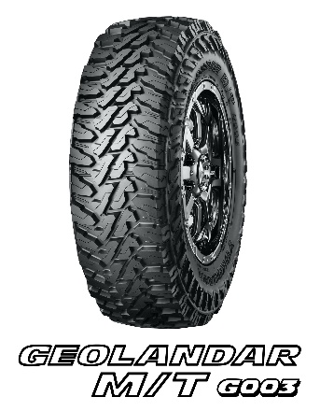
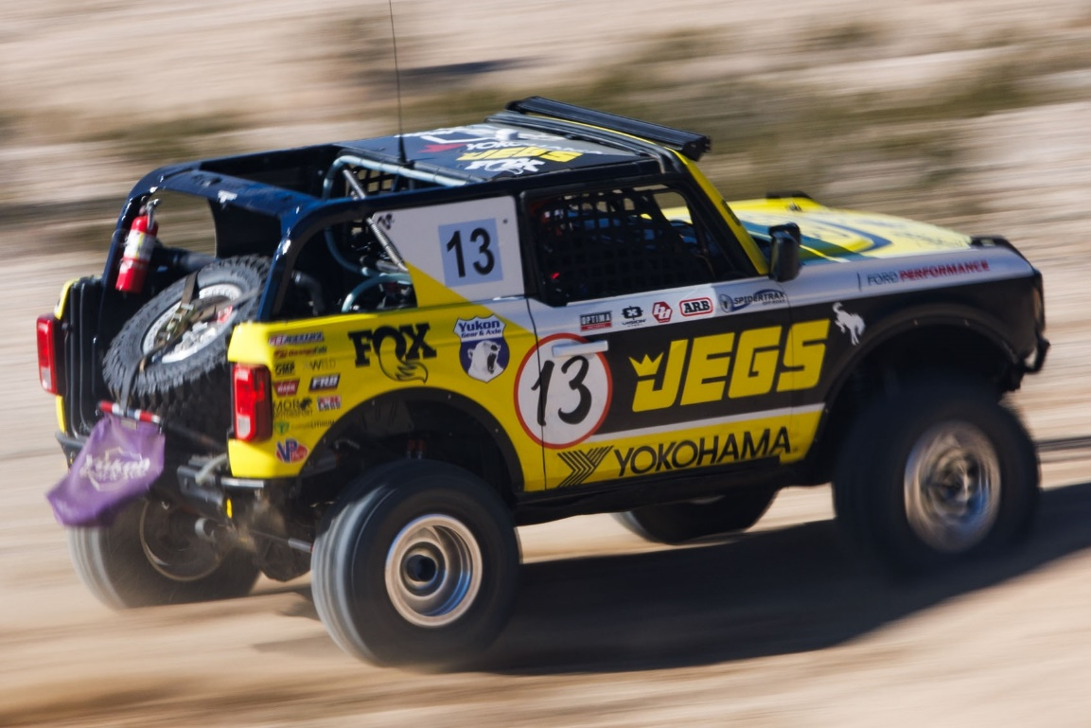
GEOLANDAR MT G003 equipped vehicle driven by Bailey Cole
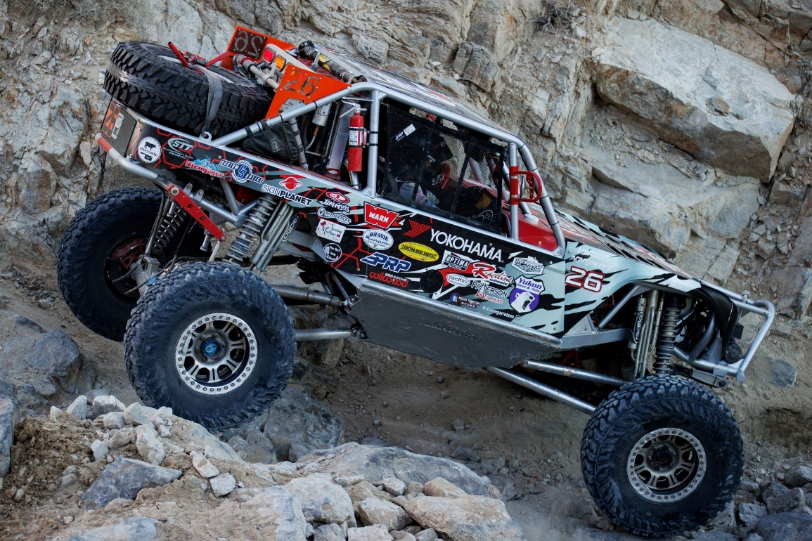
GEOLANDAR MT G003 equipped vehicle driven by Duane Garretson

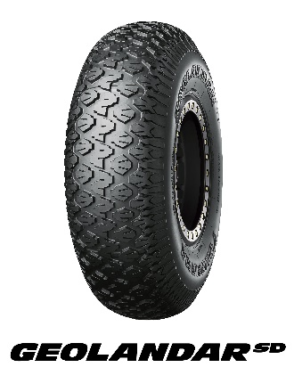

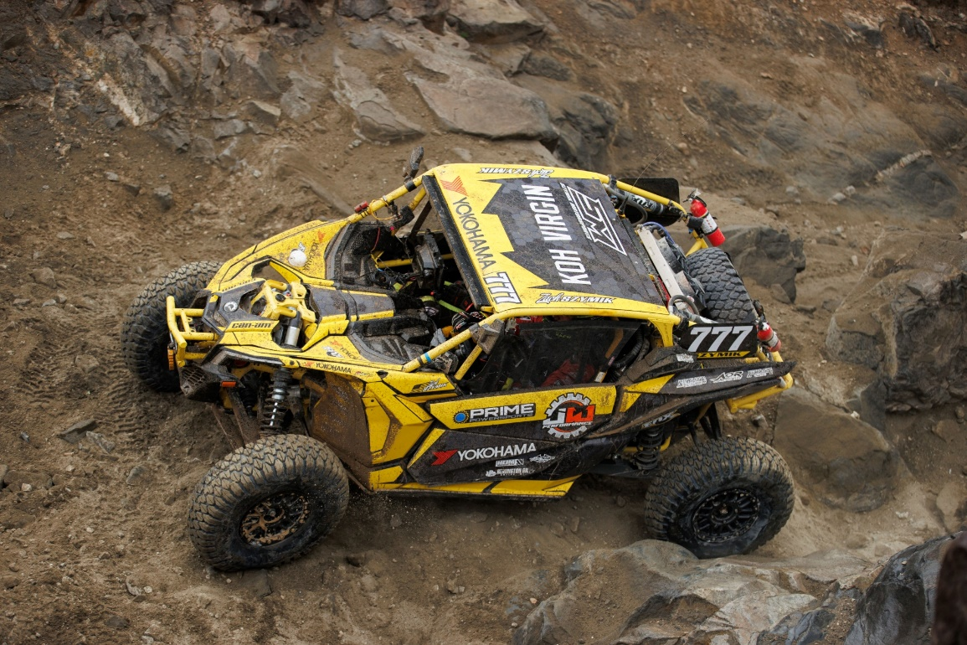
GEOLANDAR SD equipped vehicle driven by Zach Szymik

