30th November 2023

YOKOHAMA GEOLANDAR-equipped machines capture 2023 class championships in two US off-road racing series

YOKOHAMA is pleased to announce that vehicles equipped with its GEOLANDAR tyres for SUVs and pick-up trucks captured class championships for 2023 in two of the United States’ off-road racing series, Best In The Desert’s Trick Truck class and the ULTRA4 Racing’s 4900 UTV Pro Mod class.

In Best In The Desert, the largest off-road racing series in North America, two-wheel and four-wheel vehicles compete in more than 50 different classes. The ULTRA4 Racing series features open buggies called ULTRA4 vehicles competing in what is widely considered to be one of the toughest off-road races in the world. The Best In the Desert Trick Truck class series championship was won by Jonathan Brenthel driving a truck fitted with GEOLANDAR M/T G003 tyres. In the ULTRA4 Racing series, Kyle Chaney drove his buggy fitted with GEOLANDAR SD tyres to the 4900 UTV Pro Mod class championship in all regional categories, West, East and National. YOKOHAMA GEOLANDAR tyres excellent durability and performance on rugged off-road terrain contributed to the champion drivers’ strong results in race after race during the 2023 season.

After competing on YOKOHAMA tyres for the first time, Best In The Desert Trick Truck class champion Jonathan Brenthel said, “Our first year with YOKOHAMA has been nothing short of stellar! We were so excited because we knew they were willing to put in the effort to develop the tyre we need to win races and championships, and that’s exactly what they did!” ULTRA4 Racing 4900 UTV Pro Mod class champion Kyle Chaney also recognized the contribution of GEOLANDAR tyres, saying “Between the variety of tracks we race on in ULTRA4, I chose to run on the GEOLANDAR SD, because its tough sidewall prevents pinch flats and its lug design makes great traction on any surface ULTRA4 threw at us.”

YOKOHAMA’s GEOLANDAR series tyres have demonstrated outstanding off-road performance in many races over the years. The strong performance of GEOLANDAR tyres was also demonstrated in this year’s Asia Cross Country Rally, Asia’s largest cross country rally, with GEOLANDAR-equipped machines capturing the overall championship for a second straight year as well as second- and third-place.

Under YOKOHAMA’s three-year (2021–2023) medium-term management plan, Yokohama Transformation 2023 (YX2023), the consumer tyre business aims to maximize the sales ratios of high-value-added YOKOHAMA tyres, namely the global flagship ADVAN brand, the GEOLANDAR brand of tyres for SUVs and pick-up trucks, and various winter tyres. As part of its 2023 “Mud Match” themed sales campaign, the consumer tyre business is introducing new tyres in its GEOLANDAR brand and accelerating the expansion of the size line-ups.YX2023 also positions participation in motorsports activities as crucial to the company’s effort to develop new tyre technologies that will further strengthen the ADVAN and GEOLANDAR brands. YOKOHAMA therefore is again participating in a wide variety of motorsports events in Japan and around the globe, from top-category to grassroots events.

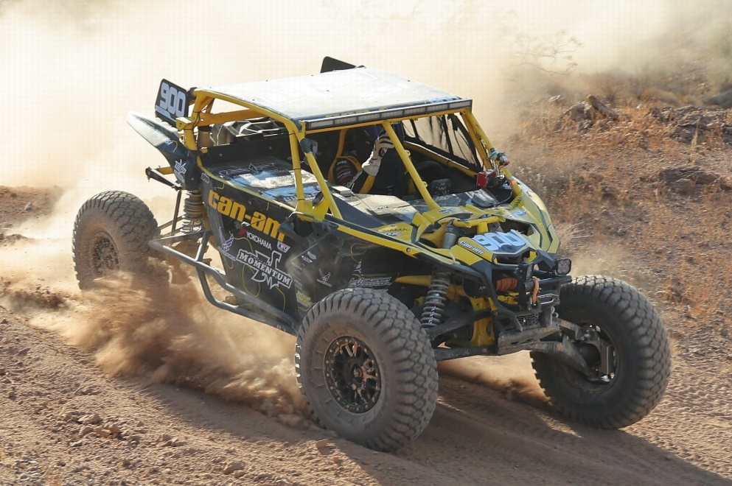
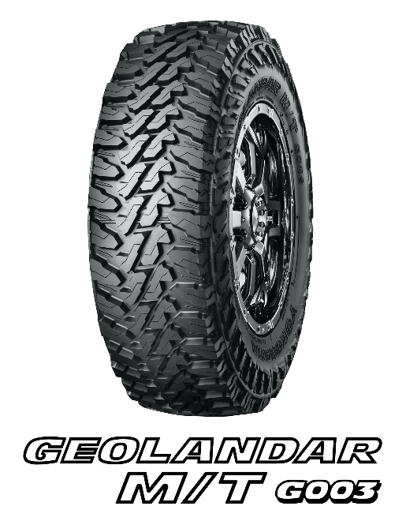
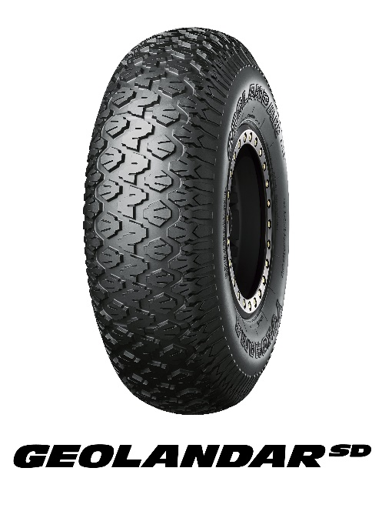
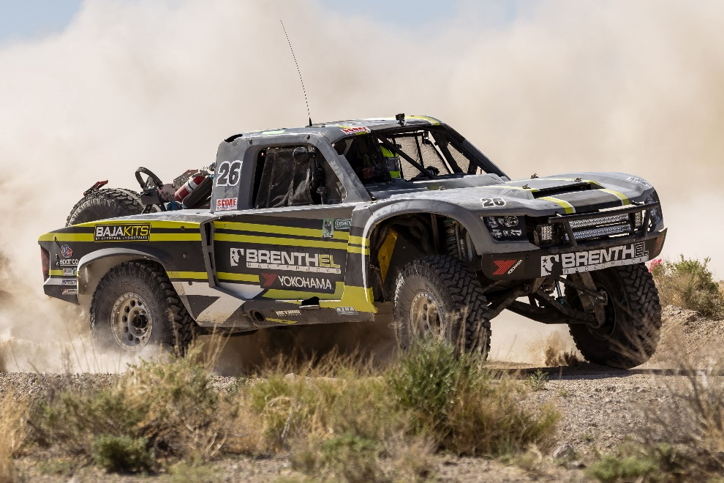
Kyle Chaney’s buggy running on GEOLANDAR SD tyres
Jonathan Brenthel’s GEOLANDAR MT G003-equipped trick truck

