13th October 2023

YOKOHAMA Europe announces Changes in Management

Düsseldorf, Germany – YOKOHAMA is pleased to announce the appointment of Mr. Giovanni Angelo Ponzoni as new Chief Executive Officer of Yokohama Europe GmbH as of 15th October 2023.

Giovanni Angelo Ponzoni brings a wealth of experience and expertise to this leadership role, with a proven track record in the tyre industry. He is known for several leading positions at Pirelli and is expected to play a pivotal role in leading Yokohama in Europe into the next phase of its growth and development.

He is following Mr. Gregorio Borgo, President and CEO of Yokohama Europe GmbH who will remain within the YOKOHAMA family as Consultant and acting President as of 1st January 2024.

Furthermore, YOKOHAMA announces the departure of Mr. Aleksandar Gramatikov, Executive Vice-President Sales, Marketing and Supply Chain of Yokohama Europe GmbH as well as the departure of Mr. Soichiro Yamaji, Executive Vice-President CFO, both with effect from 31st December 2023. Mr. Yamaji will be transferred to the Yokohama USA Subsidiary, as Executive from 1st January 2024.

Mr. Takashi Maki will be transferred from The Yokohama Rubber Co., Ltd. to Europe as new Executive Vice-President CFO, effective from 1st November 2023, together with Mr. Satoshi Miyajima who will take over the role as Vice-President Supply Chain Import Operations.

The current Chairman of Yokohama Europe GmbH, Mr. Hiroyuki Shioiri, is assigned to Head of Corporate Planning Division at The Yokohama Rubber Co., Ltd. in Japan.

YOKOHAMA expresses its deep gratitude to the departing colleagues for their unwavering commitment to the company and accomplishments within their dedicated roles. Their contributions have been instrumental in the company's growth and success.

The entire team at Yokohama Europe GmbH looks forward to working with the new employees and continuing to achieve new milestones in the tyre industry. We are confident that under the new leadership, the company will reach new heights of prosperity.

Yokohama Transformation (YX2023) is YOKOHAMA’s three-year (2021–2023) medium-term management plan, which serves as the platform for growth over the next years. YX2023’s HR strategy includes reforming the personnel system to strengthen staffing at the company’s management and administrative levels, building a stronger organization that can quickly respond to changes in the environment, and implementing work-style reforms that will benefit all employees. In line with the company’s CSR slogan "Caring for the Future," ESG initiatives will continue to focus on providing environmentally friendly products, achieving carbon neutrality, and supporting activities in communities that are home to YOKOHAMA operations. Management also will strengthen corporate governance and continue the company’s efforts to create safe, secure, and comfortable workplaces.

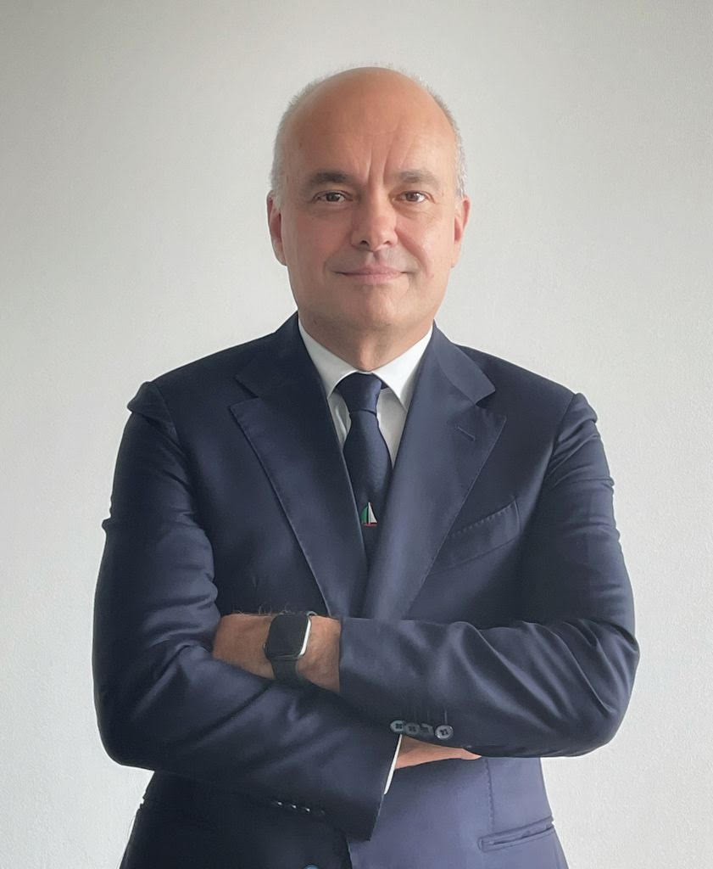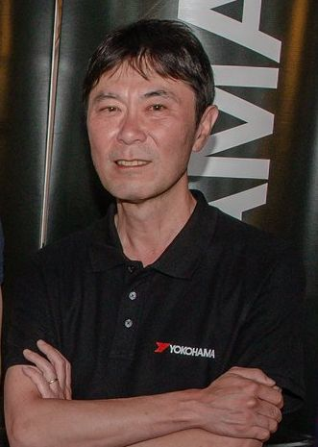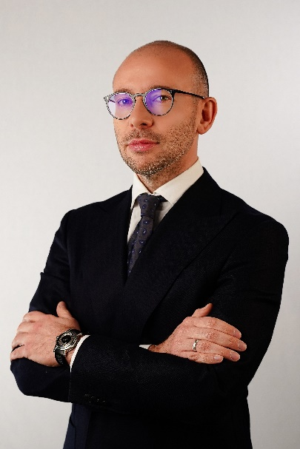
Gregorio Borgo Hiroyuki Shioiri Giovanni A. Ponzoni

