30th November 2021

YOKOHAMA Eliminates Counterfeit Aluminium Wheels in China

YOKOHAMA today announced the successful completion of its efforts to eliminate counterfeit versions of the Company’s aluminium wheels in China.

YOKOHAMA filed a complaint and submitted information to the Administration for Market Regulation in Foshan, Guangdong Province, regarding four companies engaged in the distribution of counterfeit sports car aluminium wheels imitating YOKOHAMA’s "ADVAN Racing" wheels. The distributors were selling the counterfeit wheels via internet shopping sites and retail shops outside of the Company’s official distribution channels. Acting on the complaint and information provided by the Company, the Foshan authorities simultaneously raided the four companies and seized the counterfeit aluminium wheels on 3rd September 2021. YOKOHAMA has confirmed that all four distributors have been fined and the counterfeit aluminium wheels have been destroyed.

In 2017, YOKOHAMA filed a petition for the criminal prosecution of a distributor of counterfeit versions of the Company’s aluminium wheels in China and succeeded in eliminating the counterfeit products. YOKOHAMA remains resolute in its stance against the infringement of intellectual property rights, including the sale of counterfeit goods, and will strengthen its efforts against such illegal activities in Japan and overseas to ensure that its customers around the world are confident and secure in the knowledge that they are using genuine YOKOHAMA products.

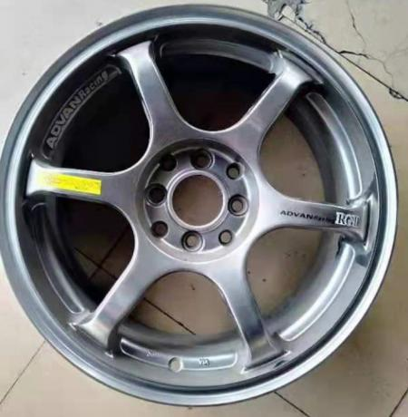
A counterfeit aluminium wheel sold in China by distributors who have been fined by the authorities

