29th September 2023

YOKOHAMA Announces Changes in Senior Management

YOKOHAMA announced today that it decided the below-mentioned changes of senior management. The changes will be effective as of October 1, 2023 and November 1, 2023.

As of October 1, 2023

 | Change in Officers’ responsibility | (current position)
Shinichi Takimoto | Senior Managing Officer, Chairman and CEO of Yokohama Corporation of North America, Chairman of Yokohama Tire Corporation, Chairman of Yokohama Tire (Canada) Inc., Chairman of Yokohama Tire Mexico S. de R.L. de C.V., In charge of O.E. Tire Sales & Marketing Div. | (Senior Managing Officer, Chairman and CEO of Yokohama Corporation of North America, Chairman of Yokohama Tire Corporation, Chairman of Yokohama Tire (Canada) Inc., Chairman of Yokohama Tire Mexico S. de R.L. de C.V.)

As of November 1, 2023

 | Change in Member of the Board’s responsibility | (current position)
Masahiro Yuki | Member of the Board and Officer, In charge of Corporate Finance & Accounting Dept., in charge of Quality Assurance Div., Chairman of Yokohama Rubber (China) Co., Ltd. | (Member of the Board and Officer, Head of Corporate Planning Div., in charge of Quality Assurance Div., Chairman of Yokohama Rubber (China) Co., Ltd.)
Hiroyuki Shioiri | Officer, Head of Corporate Planning Div., Head of Corporate Planning Dept. | (Officer, Chairman of Yokohama Europe GmbH, Chairman of Yokohama Scandinavia AB, Chairman of Yokohama H.P.T. Ltd., Chairman of Yokohama Iberia S.A., Chairman of Yokohama France S.A.S., President of Yokohama Suisse SA, President of Yokohama CEE Spółka z.o.o.)

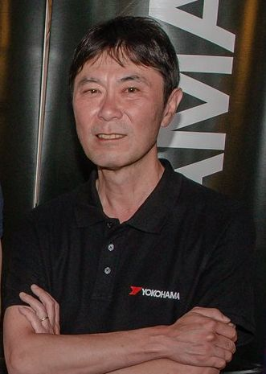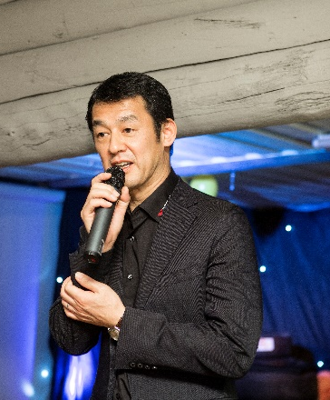
Hiroyuki Shioiri, current Chairman of Yokohama Europe GmbH
Shinichi Takimoto, former President of Yokohama Europe GmbH

