13th September 2023

YOKOHAMA ADVAN-equipped car finishes 1st in Rounds 6 & 7 of the 2023 Nürburgring Endurance Series

YOKOHAMA is pleased to announce that a car running on its ADVAN global flagship brand tyres was the overall winner of Rounds 6 & 7 of the 2023 Nürburgring Endurance Series (NLS) held consecutively on 9th & 10th September 2023. The winning car was fitted with ADVAN A005 tyres for dry conditions and ADVAN A006 tyres for wet conditions. As part of this year’s ADVAN CHALLENGE that seeks to maximize sales of ADVAN tyres during the brand’s 45th year, YOKOHAMA is supplying ADVAN racing tyres to BMW M4 GT3 cars competing in the NLS highest SP9 Pro class. The Rounds 6 & 7 winning car has now been victorious in four of the season’s first seven races, further strengthening the impression of ADVAN brand tyres and their excellent performance.

The winning car in both Round 6 and Round 7 was the #34 BMW M4 GT3 entered in the NLS SP9 Pro class by Walkenhorst Motorsport, a BMW’s customer racing team. The #34 BMW M4 GT3 started Round 6 near the back of the pack and gradually advanced to the front, taking the top position in the middle of the race and racing in the top group for the rest of the race. The #34 BMW M4 GT3 held on to the lead in the final laps and finished race 1:26.623 minutes ahead of the second-place car. The Round 6 winner started Round 7 in the 6th position but took the lead in the first half of the race and held onto it to the finish line. The ADVAN-equipped cars achieved a one-two finish in Round 7, with the #35 BMW M4 GT3 from the same team finishing second.

The NLS is an endurance race series run on the Nürburgring race track, widely considered the world’s most demanding course. Some 170 cars are competing in this year’s nine NLS races held from March to October.

Under YOKOHAMA’s three-year (2021–2023) medium-term management plan, Yokohama Transformation 2023 (YX2023), the consumer tyre business aims to maximize the sales ratios of high-value-added YOKOHAMA tyres, namely the global flagship ADVAN brand, the GEOLANDAR brand of tyres for SUVs and pick-up trucks, and various winter tyres. YX2023 also positions participation in motorsports activities as crucial to the company’s effort to develop new tyre technologies that will further strengthen the ADVAN and GEOLANDAR brands. YOKOHAMA therefore is again participating in a wide variety of motorsports events in Japan and around the globe, from top-category to grassroots events.

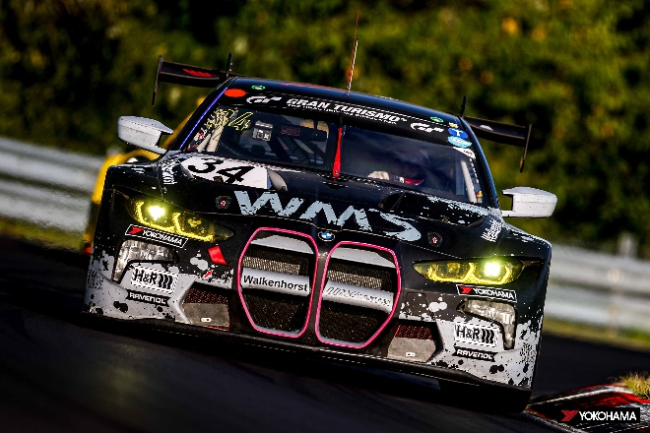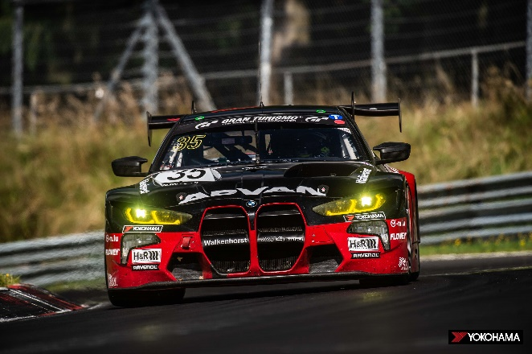
#35 BMW M4 GT3, runner-up in NLS Round 7
#34 BMW M4 GT3, winner of NLS Rounds 6 & 7

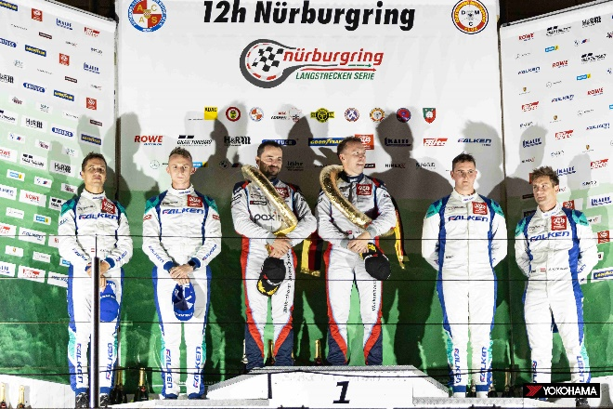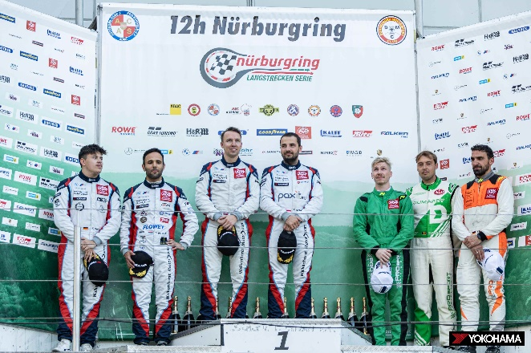
NLS Round 7 winners Christian Krognes (center left) and Jakub Giermaziak (center right) on the podium with teammates and 2nd place finishers Niklas Krütten (far left) and Dylan Pereira (second from left)
NLS Round 6 winning drivers Jakub Giermaziak (center left) and Christian Krognes (center right)

