27th September 2023

YOKOHAMA ADVAN-equipped car finishes 1st in Round 8 of the 2023 Nürburgring Endurance Series

YOKOHAMA is pleased to announce that a car running on its ADVAN global flagship brand tyres was the overall winner of Round 8 of the 2023 Nürburgring Endurance Series (NLS) held on 23rd September. The winning car was fitted with ADVAN A005 tyres for dry conditions and ADVAN A006 tyres for wet conditions. As part of this year’s ADVAN CHALLENGE that seeks to maximize sales of ADVAN tyres during the brand’s 45th year, YOKOHAMA is supplying ADVAN racing tyres to BMW M4 GT3 cars competing in the NLS highest SP9 Pro class. The Round 8 winning car has now been victorious in five of the season’s first eight races, further strengthening the impression of ADVAN brand tyres and their excellent performance.

The Round 8 winning car was the ADVAN-coloured #34 BMW M4 GT3 entered in the NLS SP9 Pro class by Walkenhorst Motorsport, a BMW’s customer racing team, and driven by Christian Krognes and Jakub Giermaziak. After finishing fifth in the qualifier, the #34 BMW M4 GT3 battled for the top spot in the first half of the race, took the lead around the race’s midpoint, and widened the gap with the rest of the field before taking the checkered flag more than two minutes ahead of the second-place car.

The NLS is an endurance race series run on the Nürburgring race track, widely considered the world’s most demanding course. Some 170 cars are competing in this year’s nine NLS races held from March to October.

Under YOKOHAMA’s three-year (2021–2023) medium-term management plan, Yokohama Transformation 2023 (YX2023), the consumer tyre business aims to maximize the sales ratios of high-value-added YOKOHAMA tyres, namely the global flagship ADVAN brand, the GEOLANDAR brand of tyres for SUVs and pick-up trucks, and various winter tyres. YX2023 also positions participation in motorsports activities as crucial to the company’s effort to develop new tyre technologies that will further strengthen the ADVAN and GEOLANDAR brands. YOKOHAMA therefore is again participating in a wide variety of motorsports events in Japan and around the globe, from top-category to grassroots events.

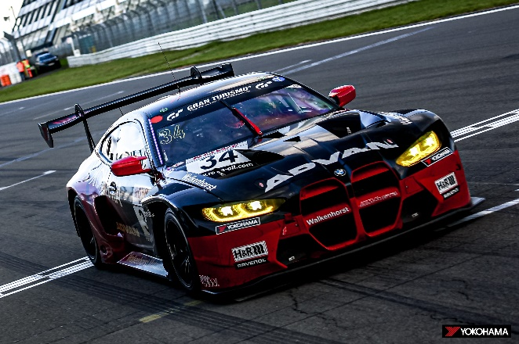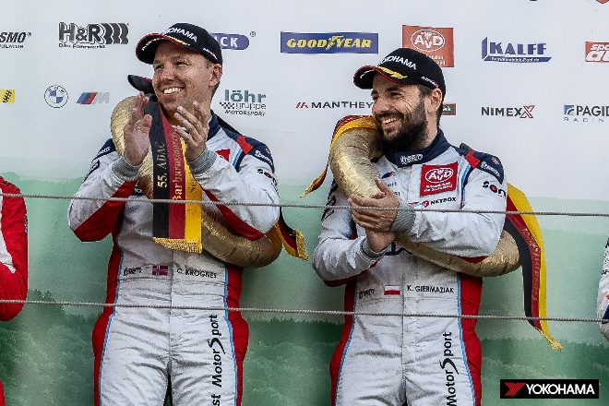
#34 BMW M4 GT3, winner of NLS Round 8
NLS Round 8 winning drivers Christian Krognes (left) and Jakub Giermaziak

