4th March 2020

YOKOHAMA to expand marketing of BluEarth-GT AE51, a grand touring tyre with excellent all-around performance

YOKOHAMA announced today that this spring it will expand marketing of its BluEarth-GT AE51, a grand touring tyre in YOKOHAMA’s BluEarth brand of fuel-efficient tyres. Launched in Japan in 2019, the tyre’s marketing will be expanded to Europe, Asia, the Middle East, Latin America, Oceania, and Africa from this spring. The BluEarth-GT AE51 will be available in 66 sizes, ranging from 245/35R19 93W to 155/65R14 75H, with the available sizes differing in each country or region.

The BluEarth-GT AE51 was developed as a grand touring tyre for mid-range sedans. It is designed to deliver excellent all-around performance, including superior manoeuvrability, comfort and environment-friendly features. The “GT” in the product name stands for “Grand Touring,” a term synonymous with long-distance driving. As such, the tyre was designed to deliver the powerful and stable driving performance appropriate for its name. The BluEarth-GT AE51 is also designed to provide greater fuel efficiency while sustaining the excellent wet-grip performance that previous BluEarth-A tyres are known for.

BluEarth-GT AE51 features a specially developed asymmetric tread pattern that delivers a comfortable ride and excellent steering stability. In addition, the tread pattern’s lightning grooves and blade-cut sipes contribute to its superior performance on wet surfaces. The tyre’s high-rigidity construction and its tread profile delivering uniform surface contact also help realize a more powerful and comfortable drive. Meanwhile, fuel efficiency has been improved by the tyre’s two-layer tread compound that suppresses energy loss due to heat generation, a side profile that reduces distortion, and a dimple shoulder design that facilitates heat dissipation.

BluEarth is a YOKOHAMA global tyre brand based on the concept of being “environmentally, human, and socially friendly”. In addition to the BluEarth-GT AE51, the BluEarth brand includes the fuel-efficient BluEarth-XT AE61 for urban SUVs high-performance; the fuel-efficient BluEarth RV-02 for multipurpose vehicles (MPVs); and the BluEarth-Es ES32, a fuel-efficient standard tyre.
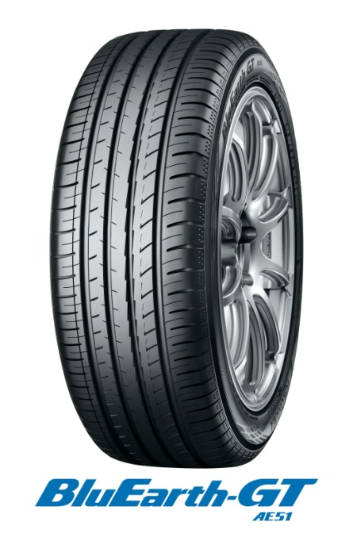

Newly-developed High-rigidity, Asymmetric Pattern
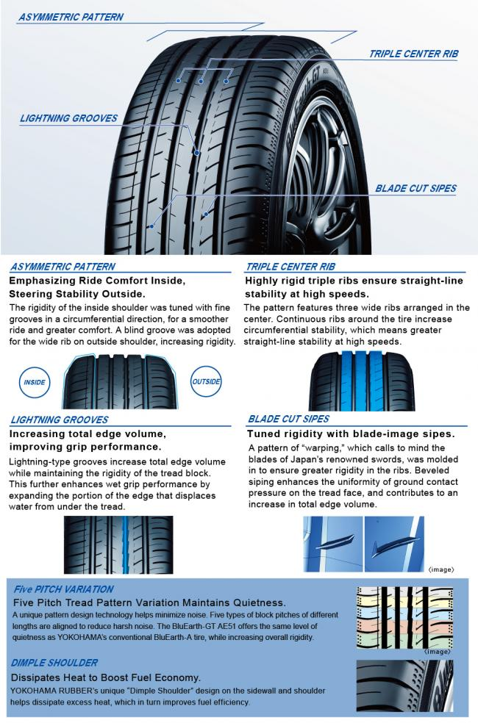

Advanced Construction Achieves Both Light Weight and High Durability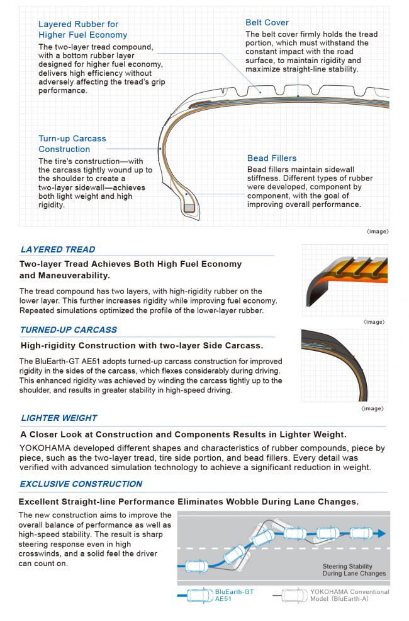

Evolved Compound. Honed Profile.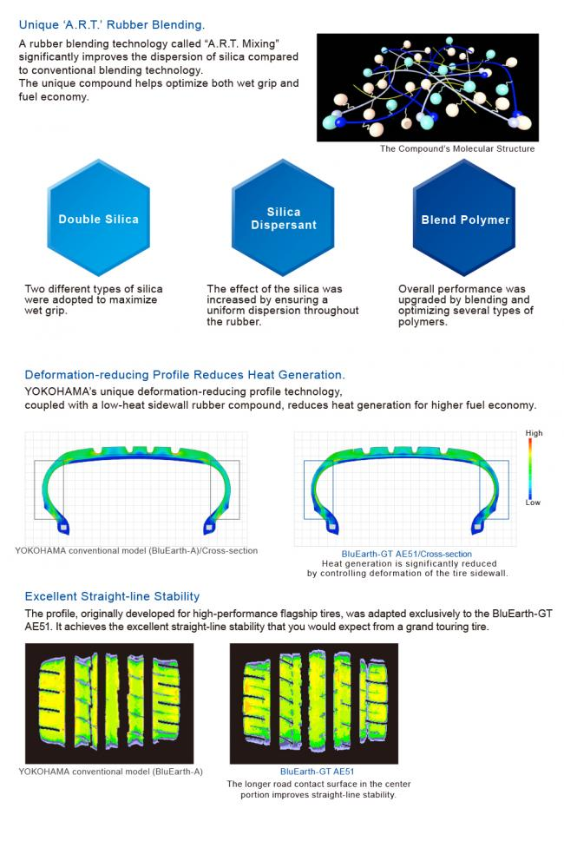

Available Sizes
