6th March 2018

YOKOHAMA to Launch the European All-Season Passenger Car Tyre, BluEarth-4S AW21

YOKOHAMA will begin European sales of its all-season passenger-car tyre “BluEarth-4S AW21” from this autumn. “BluEarth-4S AW21” will be the first YOKOHAMA all-season passenger-car tyre to be introduced to the European market. The tyre will be available in over 30 sizes, ranging from 255/50R19 107W to 175/65R14 82T. The Company plans to gradually expand the line-up of available tyre sizes.
All-season tyres are an all-weather type tyre that combines the performance of summer and winter tyres. These tyres are growing in popularity in Europe as tyres used under normal driving conditions. As they can be used year-round without concern for specific road or seasonal weather conditions, all-season tyres provide users with several benefits, such as (1) safe driving during sudden snowfalls, (2) increased convenience and economy because tyres do not need to be changed in summer and winter, and (3) the removal of the need for a place to store out-of-season seasonal tyres.
The “BluEarth-4S AW21” incorporates YOKOHAMA’s latest winter-tyre technologies to provide drivers with outstanding performance on icy and snowy winter roads as well as excellent dry and wet performance under more normal driving conditions. The tyre also features a newly developed tread pattern that features an optimal balance of edge area and surface contact area. The use of several advanced technologies, such as Divergent V-grooves and Crossing Narrow Grooves, deliver superior performance on ice, snow and wet road surfaces. In addition to its wide tread width, the tyre’s large shoulder blocks and All-season Sipes deliver reliable performance on dry roads as well.
The tyre’s use of a silica end-locked polymer compound also enhances its performance on wet and snow-covered roads. In addition, its wide and flat profile contribute to its excellent dry performance and wear resistance. The tyre also bears the “Snowflake Mark” awarded by the ASTM International* in recognition of its performance in the most severe cold climates.
* The “Snowflake Mark” is awarded to products that pass official tests conducted by ASTM International (American Society for Testing and Materials), the world’s largest standards organization.
YOKOHAMA supplies the European market with a wide line-up of products that fit the specific needs of drivers across the continent’s diverse climates. In addition to summer tyres, YOKOHAMA tyres available to drivers in Europe include winter tyres, studless tyres (Nordic friction tyres), and studded tyres. The “BluEarth-4S AW21”, YOKOHAMA’s first all-season tyre to be sold in Europe, further broadens that line-up and is expected to expand the Company’s European sales.

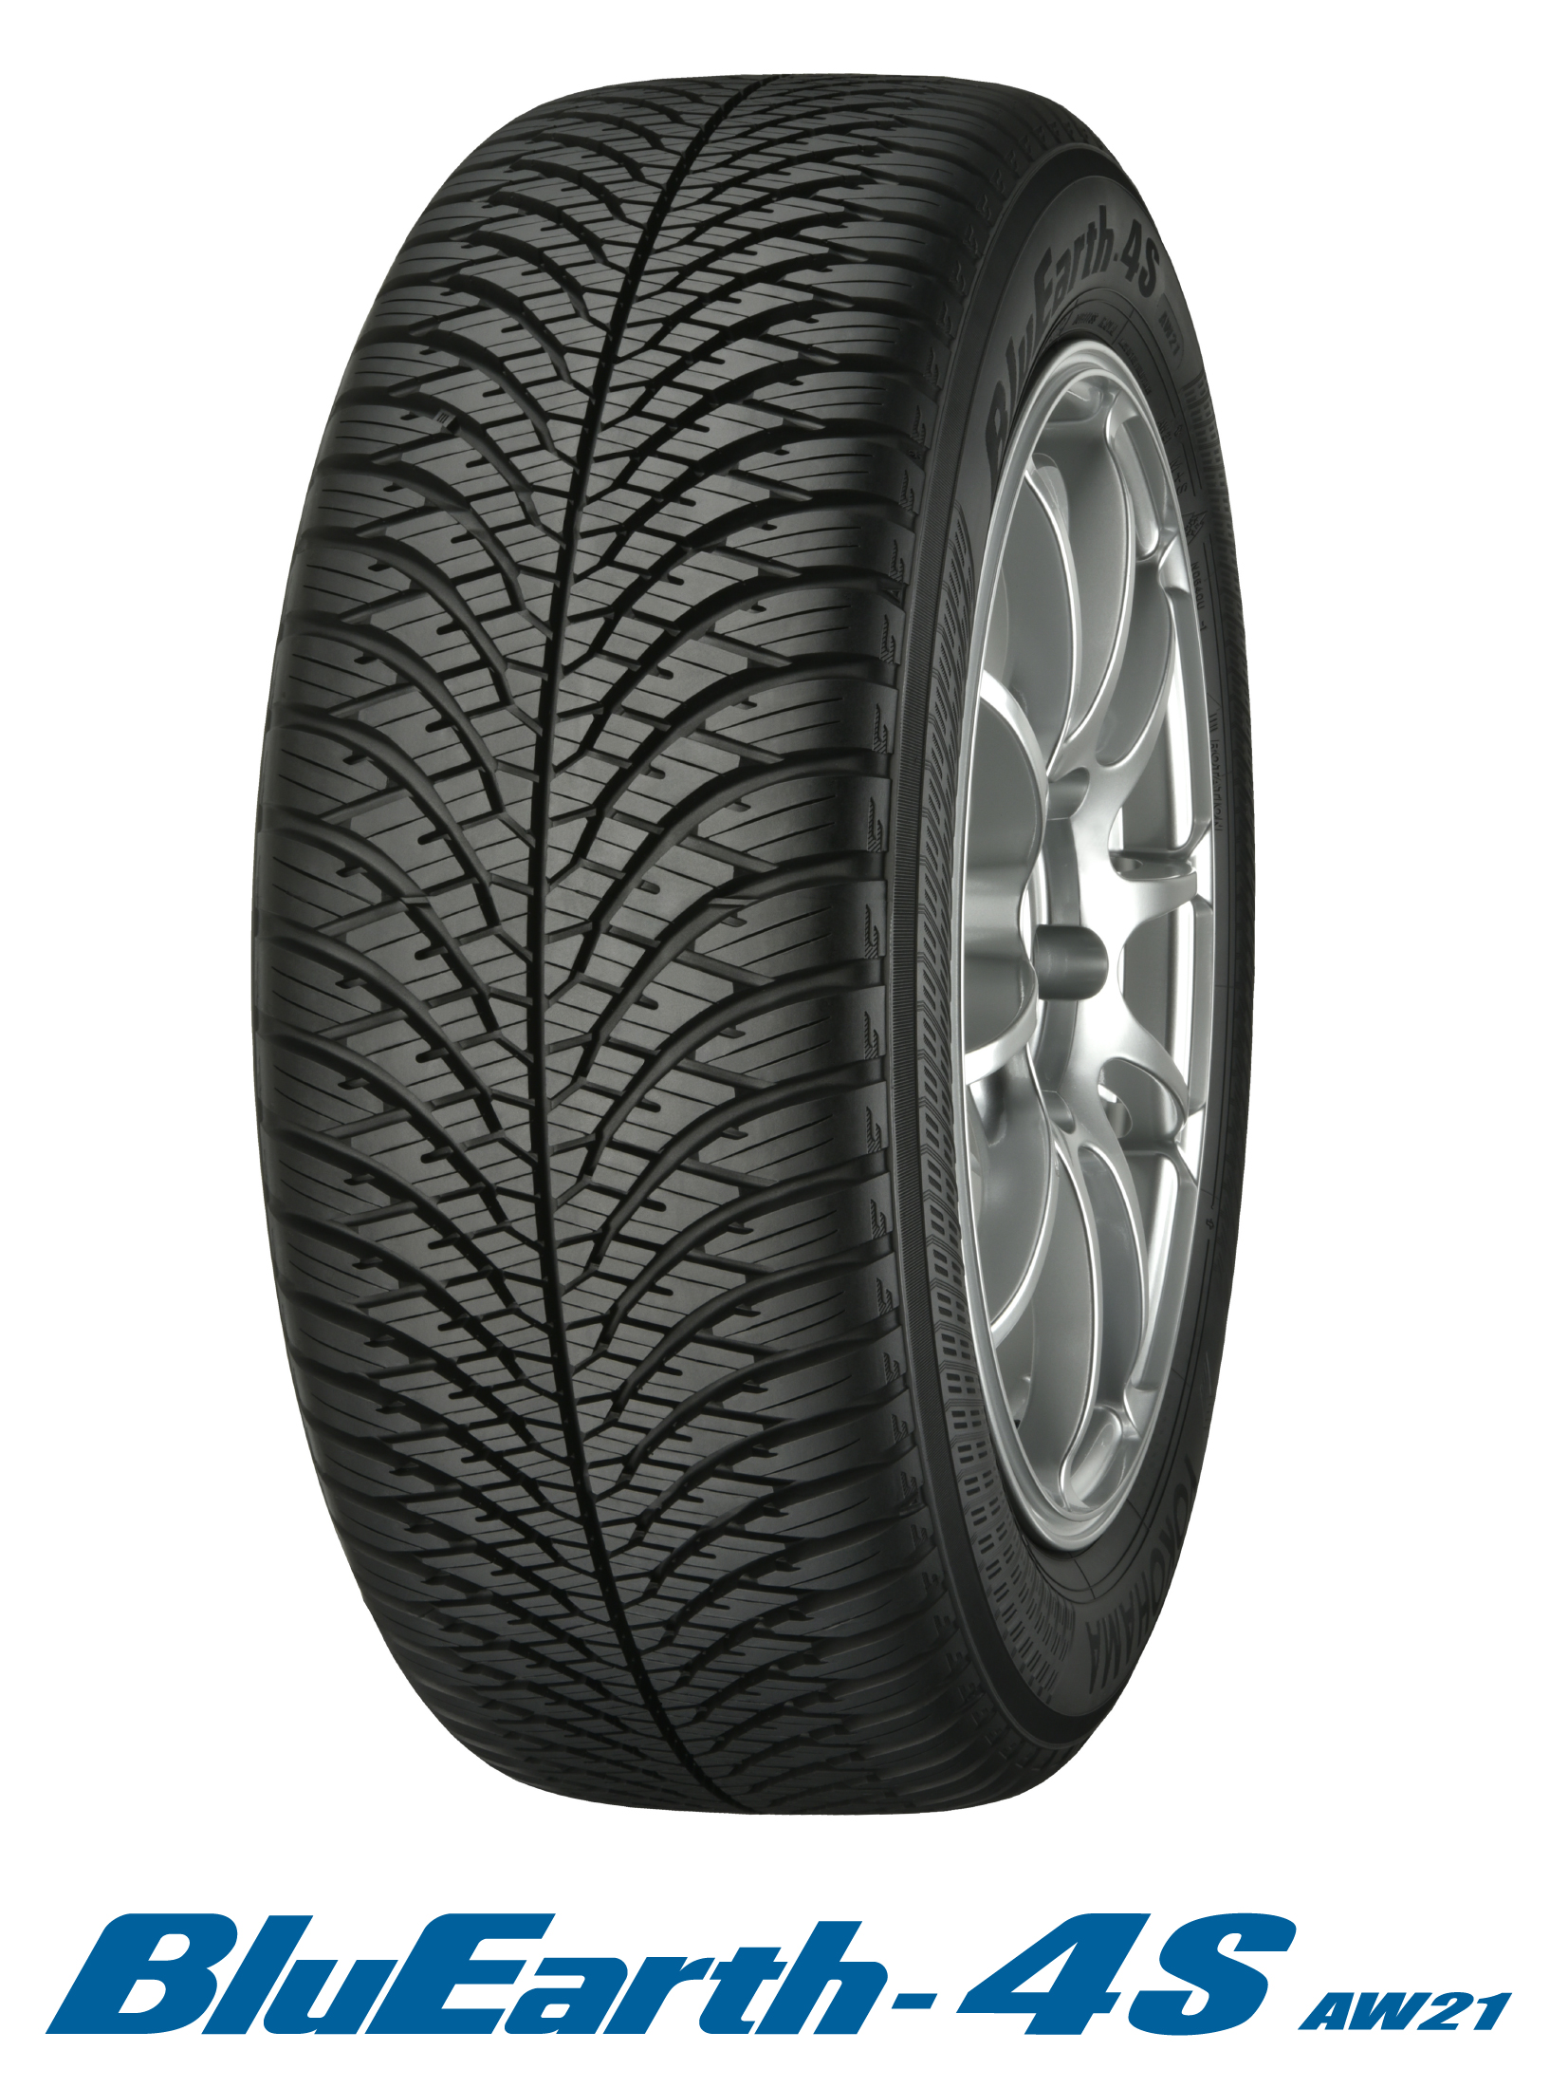
BluEarth-4S AW21

Available Sizes

