4th March 2020

YOKOHAMA to Launch European Sales of iceGUARD iG53, a Studless Tyre for Passenger Cars

YOKOHAMA announced today that it will begin sales of the iceGUARD iG53, the latest addition to its iceGUARD brand of studless tyres for passenger cars, in Europe from this autumn. The iceGUARD iG53 will be available in 16 sizes, ranging from 245/45R18 100H XL to 175/65R15 84T, 12 of which will have the H speed rating, indicating capability for running at speeds up to 210km/h.

The iceGUARD iG53 is a studless tyre for passenger cars developed using YOKOHAMA’s latest studless tyre technology and its cutting-edge BluEarth technologies. In addition to excellent performance on ice and snow, the iceGUARD iG53 delivers a superbly quiet ride, low fuel consumption, and outstanding wear resistance. It is ideal for use on a wide variety of winter road conditions, both wet and dry, from ice to compact or sherbet snow.

A new directional tread pattern featuring grooves and sipes increases the contact area and the tyre’s rigidity, maximizing the edge effect on ice and snow. The tyre’s use of YOKOHAMA’s proprietary water-absorbing rubber compound enhances its water-absorption ability, enabling it to whisk away the micro-layer of water on top of ice that results in the hydroplaning phenomenon that lifts tyres off of an icy surface. In addition, a low-heat generating under-tread rubber reduces rolling resistance and increases tyre rigidity. The tyre’s sidewall is engraved with the snowflake mark that indicates its recognition in Europe as a winter tyre.

The consumer tyre strategy in YOKOHAMA’s current medium-term management plan, the Grand Design 2020 (GD2020), includes a winter tyre strategy that aims to assert performance leadership in winter tyres supplied in Japan and overseas markets. In addition to a line-up of winter tyres, studless tyres and stud tyres, in 2018 YOKOHAMA introduced its first all-season tyre for the European market, the BluEarth-4S AW21. The company is accelerating the development of new products and expanding the size line-up of existing products.
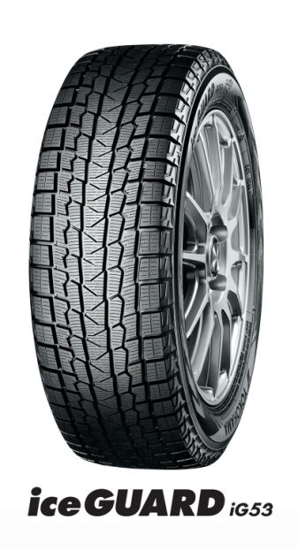

The New Directional Tread Pattern
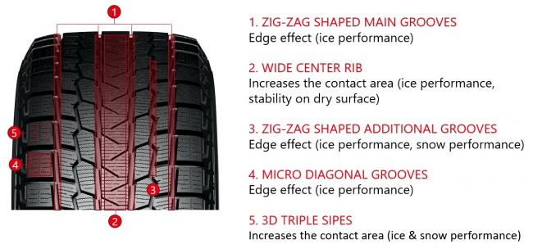

Sipes and Grooves
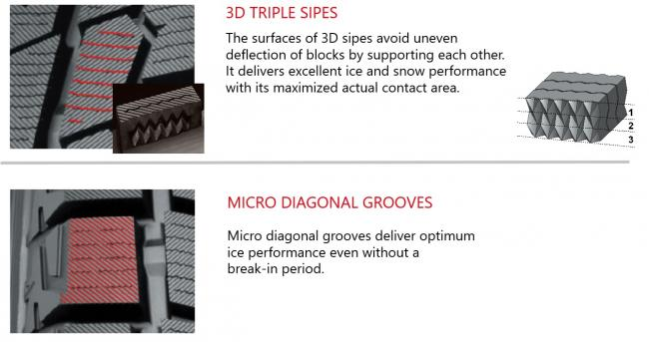

Absorptive Tread Compound
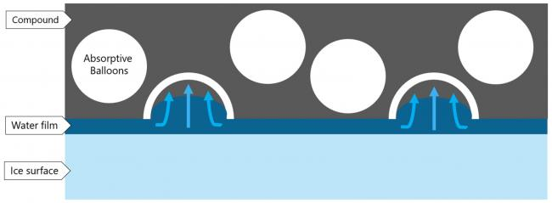

Fuel Efficient Tyre Construction

Available Sizes
