24th August 2012

YOKOHAMA exhibits at Moscow International Automobile Salon 2012

Tokyo - The YOKOHAMA Rubber Co., Ltd., announced today that it will participate in the Moscow International Automobile Salon 2012. The show will run from 29th August through 9th September (open to the public from 31st August) in Moscow, Russia. By demonstrating three distinct strengths – the high-performance of ADVAN, the "Environmentally, Human and Socially Friendly" of BluEarth, and the safety for winter of iceGUARD – YOKOHAMA is seeking to spread its brand image in Russia: “Passion, Speed, Confidence.”

YOKOHAMA is one of only a few tyre manufacturers active in the promotion of motor sports in Russia, supplying ADVAN tyres to a number of races. Building on that recognition, in the ADVAN zone at the show visitors will find many actual racing vehicles that YOKOHAMA supports and tuned cars demonstrating the high-performance of ADVAN. Among the tyres on display will be the “ADVAN A005” racing tyre, the “ADVAN Sport V105”, the next premium sport tyre model, and the “ADVAN S.T.”, a new generation of SUV tyres.

In the BluEarth zone, the “BluEarth AE-01” – a fuel-efficient tyre for passenger cars that will be released in Russia next year – will be unveiled. Also displayed will be the full BluEarth lineup sold in Russia including the environmental flagship “BluEarth-1”, and the “GEOLANDAR SUV” developed under the BluEarth concept. In the iceGUARD zone, “iceGUARD studless iG50” for passenger cars to be released in this winter season will be exhibited. Emphasis will be on technologies and new products with improved environmental performance and safety on winter roads. A wide range of other tyre products, aluminium wheels and more sold in Russia will also be shown, illustrating that YOKOHAMA is a comprehensive tyre manufacturer.

Serving Russia as one of its major markets in the world, YOKOHAMA boasts the top share there among foreign-owned tyre manufacturers. In December 2011 it opened a plant to manufacture tyres for passenger cars in Russia – the first Japanese tyre manufacturer to do so. As its sales network grows, YOKOHAMA is endeavouring to strengthen both its product-supply capabilities and marketing power.

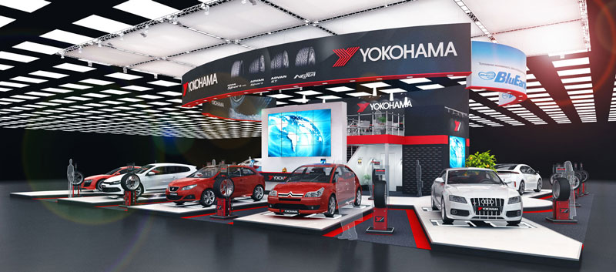

Image of the YOKOHAMA booth

