31st May 2012

YOKOHAMA Holds Opening Ceremony for New Tyre Plant in Russia

Tokyo – The YOKOHAMA Rubber Co., Ltd., announced today that YOKOHAMA R.P.Z., its tyre manufacturing/selling company in Russia, recently completed the construction of a new passenger car tyre plant in the Lipetsk Special Economic Zone in the region of Lipetsk and held an opening ceremony on the site on 30th May 2012.

Invited to the ceremony were a total of 200 people including Alexander Beglov, Authorized Representative of the President of Russian Federation in the Central Federal District, Oleg Korolev, Lipetsk Governor, Chikahito Harada, Ambassador Extraordinary and Plenipotentiary from Japan to Russia and those involved in Russian tyre sales industry. Attendees from YOKOHAMA Rubber included Chairman and CEO Tadanobu Nagumo and YOKOHAMA R.P.Z. President Shinichi Suzuki.

Chairman and CEO Tadanobu Nagumo said in his speech, “When I visited Russia in 2008, I realized that the Russian automobile society was beginning to mature and that there was a big future potential here. I then decided that it was of utmost importance to have a production plant in Russia. I had an opportunity of meeting some Russians who had come to Japan for training, and it was very reassuring to me how competent they were and how quick they were to learn skills. I am confident that in the future, we can contribute to the prosperity of Russia by supplying our YOKOHAMA-branded high-quality products to the market.”

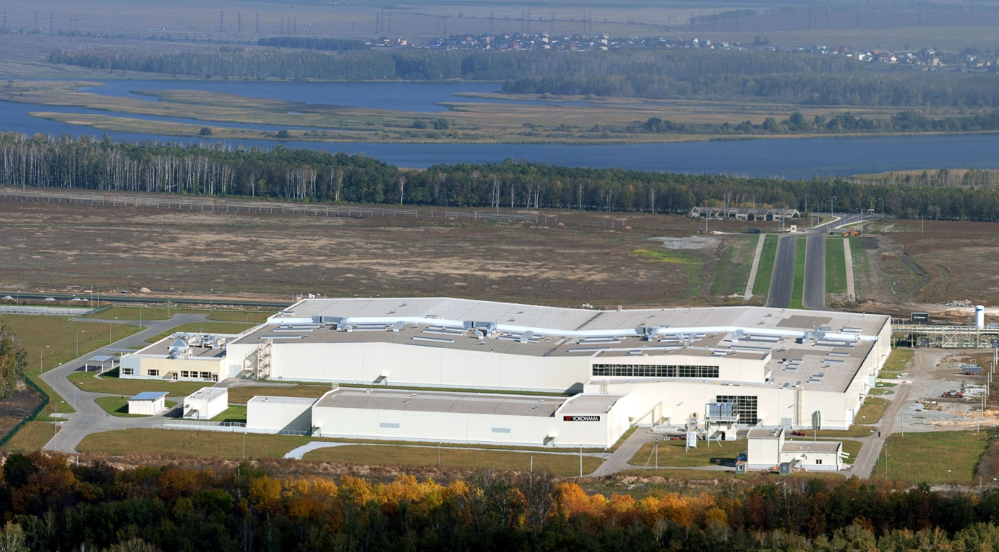

YOKOHAMA R.P.Z. was established in December 2008 to initiate tyre production in Russia. The company is currently capitalized at 3.76 billion roubles with investment ratios being 80 percent by YOKOHAMA Rubber and 20 percent by ITOCHU Corporation. Since the groundbreaking ceremony in March 2010, the company has invested 4.8 billion roubles to build the new plant. The plant, which is scheduled to go into full operation in the summer of 2013, has a building area of 4.3 hectares and an annual production capacity of 1.4 million tyres. YOKOHAMA Rubber plans to reinforce the plant’s production capacity in stages and is borrowing a 24-hectare land from the Lipetsk Special Economic Zone for future expansion.

The new plant will be manufacturing such products as passenger car tyre “C.drive2” and passenger car studded tyre “ice GUARD iG35”, both of which are core products in the Russian market and will be available in 13-18 inches in internal diameter. The products will be sold mainly in Russia with some to be exported to Europe.

YOKOHAMA has been expanding its tyre sales in Russia. The number of tyres sold in Russia in FY2011 reached approximately 3 million, a 28% increase from the previous fiscal year, and the country is now the fourth largest market for the company after Japan, the United States, and China. Centering on YOKOHAMA RUSSIA L.L.C., a tyre sales subsidiary established in April 2005, YOKOHAMA is actively reinforcing market development through large wholesalers as well as developing YOKOHAMA Club Network that targets retailers. In addition to these efforts to increase sales force, local production enabled by the new plant will help further expand business by strengthening and speeding up product supply.

