14th February 2019

YOKOHAMA Announces Changes in Senior Management

YOKOHAMA announced today that it informally decided changes of the senior management at the meeting of the board members held on 14th February 2019 as per download.
The changes will formally be approved after the general meeting of shareholders to be held on 28th March 2019.
As of 28th March 2019:

Promoted Member of the Board
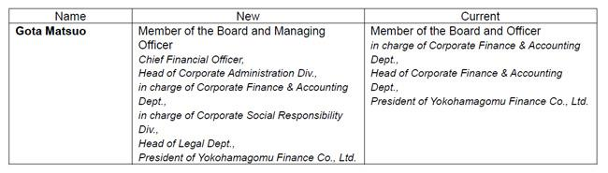

Newly appointed Member of the Board
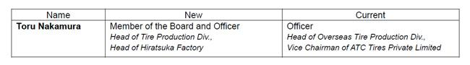

Change of Audit & Supervisory Board Member’s position
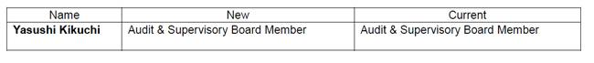

Newly appointed Audit & Supervisory Board Members
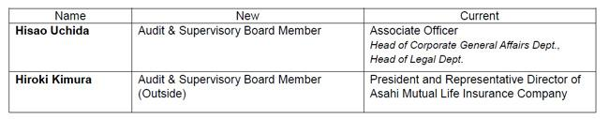

Newly appointed Officers
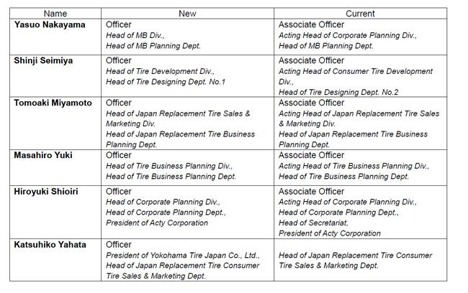

Retired Members of the Board
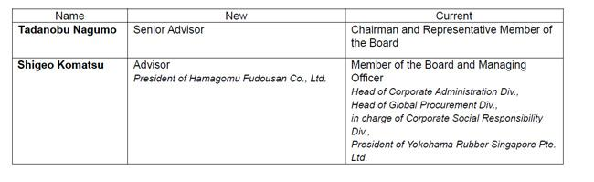

Retired Audit & Supervisory Board Members

Retired Officers
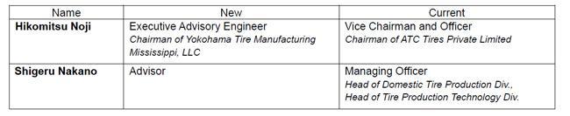

Changes in Member of the Board’s responsibility
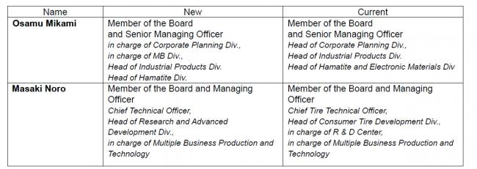

Changes in Officer’s responsibility
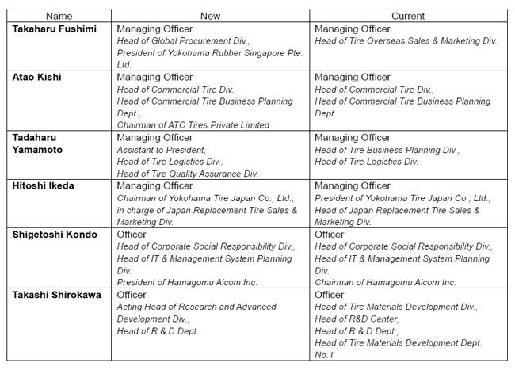

New Management
YOKOHAMA plans to establish the following new management after the general meeting of shareholders to be held on 28th March 2019:

Members of the Board
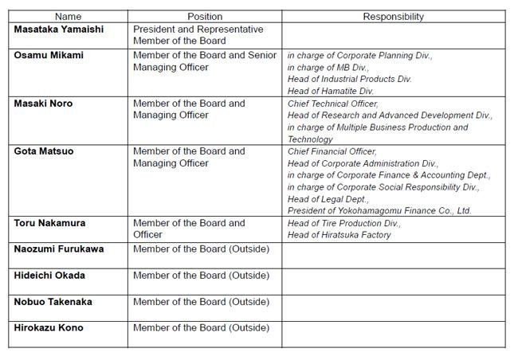

Audit & Supervisory Board Members
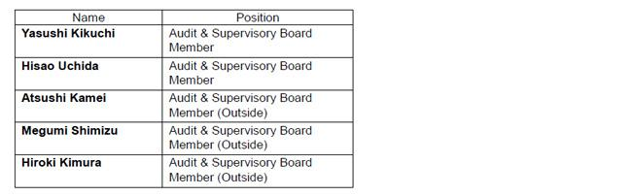

Officers
