21st May 2023

Walkenhorst Motorsport finishes topsy-turvy Nürburgring 24-hours second-best BMW entry

24h Nürburgring Race Report
Date | 20-21 May 2023
Course | Nürburgring (Germany)
Weather | After 24hours: Fine
Surface | After 24hours: Dry
Walkenhorst Motorsport and YOKOHAMA finished the 51st edition of the Nürburgring 24-hours in style with the #100 art car. Henry Walkenhorst, Jörg Breuer, Sami-Matti Trogen and Christian Bollrath achieved a trouble-free race in 5th position in the SP9 Pro-Am class.
Applying a cautious approach, the team managed to stay out of trouble in an all-dry race twice around the clock on the legendary “Green Hell” Eifel circuit, gradually climbing up the leaderboard to finish 16th overall in front of 235,000 spectators that once more created the unique festival atmosphere the race is well-known for.
Albeit entered in the Pro-Am category, the #100 came home as second-best BMW team overall, underlining the strong performance of the latest YOKOHAMA ADVAN racing slick tyres for the Nürburgring Nordschleife. After early contact with a smaller car misjudging its braking point, the #100 drivers kept their nose clean and proved once more that dealing swiftly with tough conditions in the Nürburgring 24-hours involving oil spills, debris and dirt on the road pays off.
The two YOKOHAMA-liveried BMW M4 GT3 entered in the SP9 Pro category experienced a tough race after showing a strong performance until their eventual retirement due to incidents involving lapped traffic.
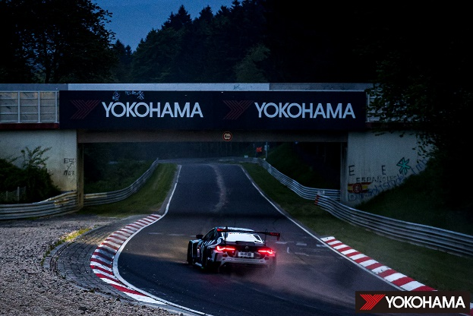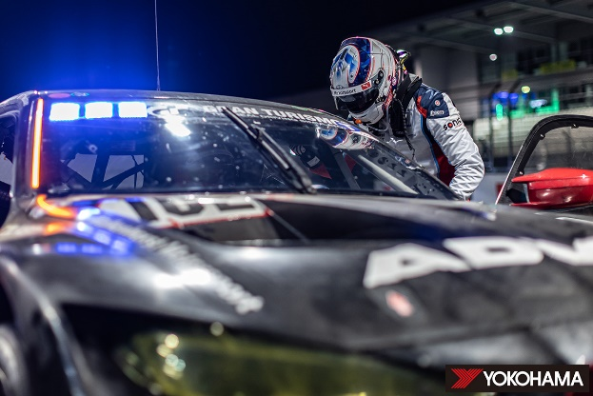
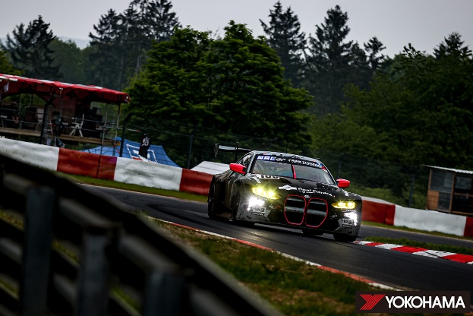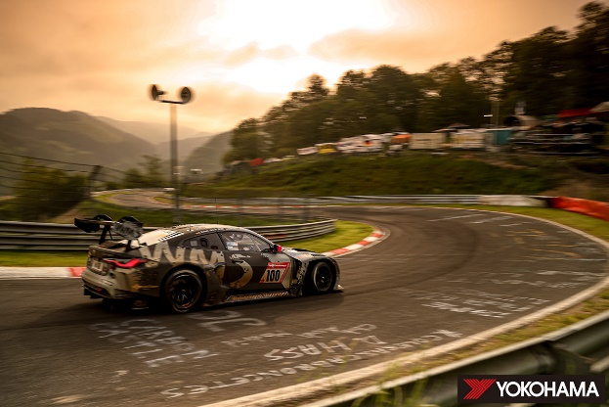
Having climbed as high as sixth from 27th starting position, the #101 entry shared by Nordschleife-NLS-track-record-holder Christian Krognes, former Porsche Supercup ace Jakub Giermaziak, BMW factory driver Jesse Krohn and former FIA Formula Two champion Andy Soucek was on course to a top result, possibly challenging for the podium, when two unfortunate incidents ended the race prematurely.
The #102 entry achieved its first victory way ahead of the start when the highly professional Walkenhorst Motorsport outfit managed to repair the BMW M4 GT3 overnight after contact with the barriers in top qualifying on Friday. Starting from last place in its group, 2022 Nürburgring 24-hours GT4 winner Thomas Neubauer, ABB FIA Formula E star Jake Dennis, BMW factory driver Jens Klingmann and Christian Krognes relied on the grip and steady performance of their YOKOHAMA ADVAN slick tyres to charge through the field, making up 18 positions in the first hour with their repaired car.
Steadily climbing up the order, the #102 looked like a strong challenger for the podium positions when the challenge really came alive at night on the soft compound ADVANs. Trying to break into the top 3 with morning approaching, a misunderstanding with slower traffic forced Neubauer to take avoiding action off track, damaging the underbody of the BMW in the process. A strong challenge came to an unfortunate premature end.
Both Walkenhorst Motorsport and YOKOHAMA are already setting their sights on the next races of the Nürburgring endurance series, starting their challenge for the 2024 Nürburgring 24-hours.

Driver’s Voice: Henry Walkenhorst [No.100 / SP9 Pro-Am Class – Team Owner and Driver]
“Of course, the result this weekend is not what we have hoped for. Having had damage in qualifying, the team did an incredible repair job overnight. But as we all know, the Green Hell can bite you. Unfortunately, we lost both our Pro entries due to unfortunate incidents. The #100 has run faultlessly. It is a bit mixed feelings as we were hoping for more. We are very happy with the YOKOHAMA tyres as we didn’t have a single puncture all weekend long. That was exceptional. Sometimes you just don’t have lady luck on your side. We will now focus on the next NLS races, aiming for more victories there to come back stronger next year.”

Engineer’s Voice: Masaaki Miyoshi [The Yokohama Rubber Co., Ltd. Motorsports Tyre Development Dept. No.1 Tyre Development Division]
“For sure, our ambition has been overall victory. We put in hard work from NLS1 to NLS3 and the N24-Qualifiers as we know the level in SP9 here is very high with very professional drivers and teams.
Considering this, we have shown a good performance. But we also had to realize again how hard it is to climb the podium in this race. We have received very good feedback from the drivers about our tyres.
Furthermore, everyone within the team understands the BMW M4 GT3 better than during its debut year which helps a lot. But the path to victory is a tough one, so we must put in more hard work on the way to achieve our goal. We will now focus on the Nürburgring Endurance Series where we won the championship in 2020. We hope to continue our strong relationship with Walkenhorst Motorsport for further future endeavors in the Green Hell.”

