World Touring Car Championship takes a break before the final rounds

The FIA World Touring Car Championship takes a well deserved break for the next few weeks and will resume the competition on the 22nd and 23rd September at the Championship’s first visit to Sonoma’s Infineon Raceway in the USA.

Following the excitement at the last event in Curitiba, Brazil and with the Asian rounds also promising sparks and thrills towards the last quarter of 2012, everything is still undecided with no clear winner as yet.

Current leaders and going strong are Yvan Muller 287 pts, Rob Huff 270 pts and Alain Menu 250 pts all belonging to the Chevrolet team, who already announced they will not be competing at WTCC next season after a change in the manufacturer’s strategy, recently stated they are still absolutely focused to ensure they manage to achieve a Chevrolet 1, 2, 3 at the end of the season.

However the competition is still open and the likes of Gabrielle Tarquini, currently fourth in the table with 162 pts, will also use all his experience to try and climb a position and make it very difficult for the Chevrolet trio.

The battle for the YOKOHAMA Trophy, also popularly known as the “independent’s trophy”, has intensified after Hungarian hero, Norbe Michelisz 111 pts now leads after overtaking the young Spaniard Pepe Oriola 106 pts following his excellent performance in Brazil. Meanwhile the up and coming young British driving talents currently on their maiden season at the FIA WTCC, such as James Nash, Alex Macdowall and Tom Chilton are also hoping to obtain some more valuable experience and gathering points as they face their first US experience.

Commenting on the season so far David Oliva, Yokohama Europe’s Marketing Communications and Motorsports Project Manager expressed satisfaction at the way the ADVAN racing tyres had endured and competed at the highest level under increasingly demanding conditions and longer distances this season. “As Official Tyre partners for the WTCC, “The YOKOHAMA Motorsport team is continuously testing, working in R&D projects and improving our technology in order to guarantee the highest performance and competitiveness at every racetrack”.

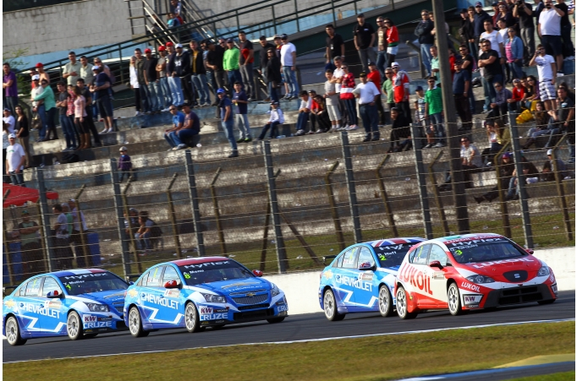

Notes to Editors
YOKOHAMA is one of the leading Tyre manufacturers in the world and is Official Tyre supplier for;
FIA World Touring Car Championship (WTCC) – since 2006
European Touring Car Cup (ETCC) – since 2005
Intercontinental Rally Challenge (IRC) – since 2007
Scandinavian Touring Car Championship (STCC) – since 2010
Russian Touring Car Championship (RTCC) – since 2006
Chinese Touring Car Championship (CTCC) – since 2010
Irish Touring Car Championship (ITCC) – new for 2012
International Formula 3 Grand Prix Macau – since 1983
ATS German Formula 3 – until 2005 and since 2007
FIA F2 Championship – new for 2012
Japanese Formula 3 – since 2011
ADAC GT Masters new for 2012
GT Asia new for 2012

