YOKOHAMA Success in Russia – Lada Granta Cup in Togliatti

The home town of the Russian car manufacturer LADA, witnessed exciting racing during an eventful weekend for YOKOHAMA. From the 26th-27th May, the second stage of the racing championship took place with significant support of many hundreds of spectators who took to the urban track in the city centre of Togliatti.

YOKOHAMA Russia was well represented at the event by providing Motorsport support as well as providing technical assistance.

The city, turned into a race track for the weekend, enjoyed large crowds and a good number of guests from YOKOHAMA Russia, including local dealers and Japanese citizens who are now working at the LADA factory.

In this partnership between YOKOHAMA and LADA, the young Mikhail Tyagunov, YOKOHAMA Russia Technical specialist and former professional driver was given the opportunity to join the race weekend doing extremely well, after a long time away from Motor racing. Mikhail achieved two podium places coming in as runner up on both races. In the first race, Mikhail battled with the field on a dry surface to be beaten narrowly by Yuri Loboda. The second race however followed heavy rain which meant wet tyres had to be used and this time, last year’s Russian Touring Car Champion Alexander Frolov who had joined in with the Kaspiy Lada team managed to cross the line in front of the pack, with Mikhail closely following.

YOKOHAMA is official tyre supplier for the Lada Granta Cup.

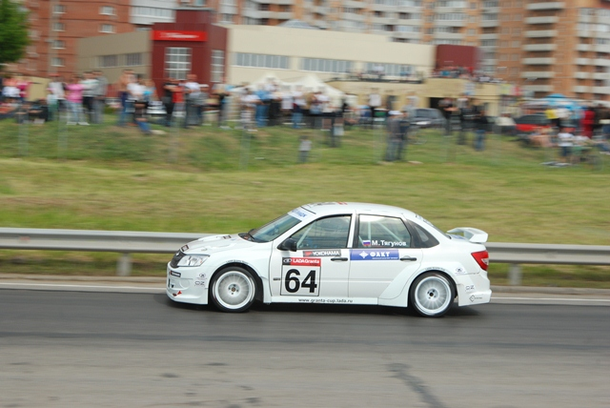

Notes to Editors
YOKOHAMA is one of the leading Tyre manufacturers in the world and is Official Tyre supplier for;
FIA World Touring Car Championship (WTCC) – since 2006
European Touring Car Cup (ETCC) – since 2005
Intercontinental Rally Challenge (IRC) – since 2007
Scandinavian Touring Car Championship (STCC) – since 2010
Russian Touring Car Championship (RTCC) – since 2006
Chinese Touring Car Championship (CTCC) – since 2010
Irish Touring Car Championship (ITCC) – new for 2012
International Formula 3 Grand Prix Macau – since 1983
ATS German Formula 3 – until 2005 and since 2007
FIA F2 Championship – new for 2012
Japanese Formula 3 – since 2011
ADAC GT Masters new for 2012
GT Asia new for 2012

