WTCC Salzburgring - YOKOHAMA “Running On Track”

The first edition of the YOKOHAMA “Running on Track” event took place at WTCC Salzburgring last weekend.

Over 40 people including WTCC Drivers Tom Chilton, James Nash, Stefano D’Aste, Pasquale di Sabatino among others, together with engineers, sponsors, mechanics, journalists and many others involved in the organization of the World Touring Car Championship took part in the one lap (4.2km) around the Salzburgring. Other WTCC drivers and members of the organisation also cheered their colleagues from the comfort of bicycles and golf carts.

The event planned to be continued at other tracks around the World Touring Car Championship hopes to offer the WTCC Family and everybody connected with it a fun, ecological, competitive event that brings people together in Friendship and Sportsmanship.

In Salzburgring, the first 25 to cross the line were presented with certificates by Mr Susumu Watanabe, Chief Engineer for WTCC of the Yokohama Rubber Company.

The next “Running on track” will be held at WTCC Portimao (Portugal) on Friday 1st June at 19.00hrs.

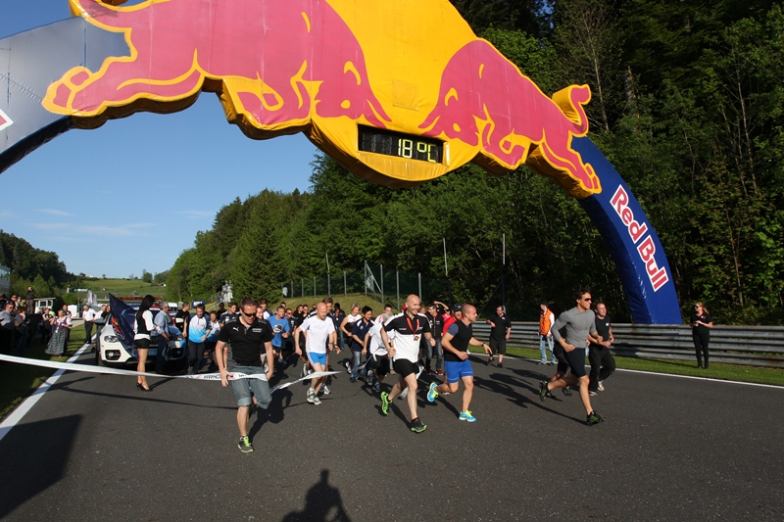

Notes to Editors
YOKOHAMA is one of the leading Tyre manufacturers in the world and is Official Tyre supplier for;
FIA World Touring Car Championship (WTCC) – since 2006
European Touring Car Cup (ETCC) – since 2005
Intercontinental Rally Challenge (IRC) – since 2007
Scandinavian Touring Car Championship (STCC) – since 2010
Russian Touring Car Championship (RTCC) – since 2006
Chinese Touring Car Championship (CTCC) – since 2010
Irish Touring Car Championship (ITCC) – new for 2012
International Formula 3 Grand Prix Macau – since 1983
ATS German Formula 3 – until 2005 and since 2007
FIA F2 Championship – new for 2012
Japanese Formula 3 – since 2011
ADAC GT Masters new for 2012

