19th October 2012

The 2012 FIA Formula Two described as a resounding success

The recently concluded FIA F2 season has been a resounding success according to participants, drivers, organisers and partners of the event.

For the first time, YOKOHAMA supplied the A005 Dry slick and A006 Wet tyres to the entire Formula 2 grid. The control tyres supplied by Yokohama HPT Ltd - The UK distributor for the Japanese Tyre manufacturer - were a bespoke item developed specifically for the Williams Grand Prix-designed single-seater chassis.

Introduced at the pre-season test, along with carbon brakes, the YOKOHAMA tyres immediately contributed to a reduction in lap times of around two seconds per lap from the previous season. Drivers reported excellent grip, consistency and longevity from the tyres, which are limited to four sets of slicks and two sets of wets per driver per double race weekend.

The series visited some of Europe's most iconic racetracks, including Silverstone and Brands Hatch in the UK, Spa-Francorchamps in Belgium, Nürburgring in Germany and Monza in Italy, as well as some of Europe's newest and challenging circuits, such as Autodromo do Algarve in Portugal.

The consistency of the YOKOHAMA tyres throughout race weekends and the races themselves led to some exceptional racing for the 500bhp single-seater, slicks-and-wings Williams-designed cars. There were no less than seven different race winners throughout the season and the 2012 driver championship went down to the wire at the very last race of the season in Italy.

British driver Luciano Bacheta eventually won the series and with it, a test with the Williams Formula One team and his FIA super license, required to test and compete in F1.

Summing up the F2 season, Head of Motorsport at Yokohama HPT Ltd, Mark Evans, said; "It has been a superb season for us this year in Formula Two. Of course, it started at the end of 2011, with pre-season testing to establish the exact specification for the tyres but it was clear immediately that lap times in 2012 would be significantly quicker than in previous years - around two seconds a lap at some circuits. "We saw seven race winners across 16 individual races; we had dry, damp and very wet conditions and I am very pleased with the way our tyres performed in all conditions.”
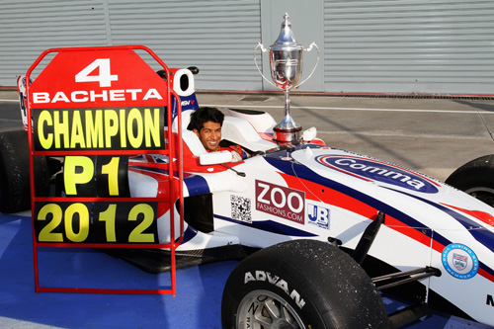

Notes to Editors
YOKOHAMA is one of the leading Tyre manufacturers in the world and is Official Tyre supplier for;
FIA World Touring Car Championship (WTCC) – since 2006
European Touring Car Cup (ETCC) – since 2005
Intercontinental Rally Challenge (IRC) – since 2007
Scandinavian Touring Car Championship (STCC) – since 2010
Russian Touring Car Championship (RTCC) – since 2006
Chinese Touring Car Championship (CTCC) – since 2010
Irish Touring Car Championship (ITCC) – new for 2012
International Formula 3 Grand Prix Macau – since 1983
ATS German Formula 3 – until 2005 and since 2007
FIA F2 Championship – new for 2012
Japanese Formula 3 – since 2011
ADAC GT Masters – new for 2012
GT Asia – new for 2012

