8th May 2012

YOKOHAMA DENMARK SUPPORTS WORTHY CAUSE

The International Racing Festival in Copenhagen held recently, saw intensive participation by YOKOHAMA Denmark who serviced many of the participating cars as exclusive tyre partner.

The event which is traditionally hosted by HRH Prince Joachim of Denmark is a fundraising event which collects money for the Danish Red Cross. The concept is that visitors can donate money to ride with a top driver in an exciting car. There are different price categories from small group N race cars up to super cars such as Aston Martin, Mercedes, Ferrari, Lamborghini, Bugatti.

The net profit from the event, this year reached dkr. 2,152,000 (around Euro 289,000) which was handed over to the Danish Red Cross at a presentation ceremony which officially closed the succesful event.

Around 40,000 spectators visited the festival, which took place in the centre of Copenhagen next to the old Carlsberg plant.

YOKOHAMA Denmark also took the opportunity to demonstrate the Advan Neova on some of the spectacular cars including that of former F-1 driver Nicolas Keisa’s Lamborghini with nearly 1000 HP. YOKOHAMA branding was also very evident throughout the event, including 500 metres of YOKOHAMA banners which were well displayed along the 2.2km temporary urban circuit.

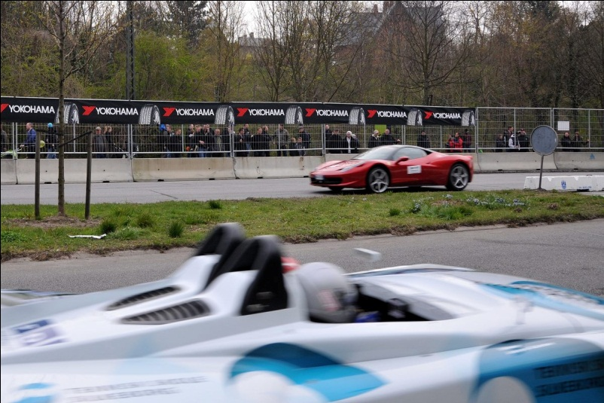

Notes to Editors
YOKOHAMA is one of the leading Tyre manufacturers in the world and is Official Tyre supplier for;
FIA World Touring Car Championship (WTCC) – since 2006
European Touring Car Cup (ETCC) – since 2005
Intercontinental Rally Challenge (IRC) – since 2007
Scandinavian Touring Car Championship (STCC) – since 2010
Russian Touring Car Championship (RTCC) – since 2006
Chinese Touring Car Championship (CTCC) – since 2010
Irish Touring Car Championship (ITCC) – new for 2012
International Formula 3 Grand Prix Macau – since 1983
ATS German Formula 3 – until 2005 and since 2007
FIA F2 Championship – new for 2012
Japanese Formula 3 – since 2011
ADAC GT Masters new for 2012

