31st August 2023

Cars running on YOKOHAMA’s global flagship ADVAN brand tyres finish one-two in GT300 class at SUPER GT’s 5th round

YOKOHAMA is pleased to announce that cars equipped with its global flagship ADVAN brand tyres finished in first and second place in the GT300 class in Round 5 of the 2023 AUTOBACS SUPER GT Series, Japan’s ultimate touring car racing series. Round 5 was held on 26th and 27th August at the Suzuka Circuit in Mie Prefecture. The ADVAN tyres’ high performance supported the winning team as it raced to victory and keeps ADVAN on pace for achieving the back-to-back GT300 class championship that YOKOHAMA is aiming for as part of this year’s ADVAN CHALLENGE, which seeks to maximize sales of ADVAN tyres during the brand’s 45th year.

The winning car in Round 5, which is the first race in the second half of the series, was TEAM UPGARAGE’s UPGARAGE NSX GT3, whose drivers were Takashi Kobayashi and Syun Koide. UPGARAGE NSX GT3 started the final race in the 16th position. Taking the wheel for the first stint, Kobayashi gradually advanced their position before switching with Koide during the first pit stop. During his long stint, Koide took advantage of the FCY (full course yellow) to make his second pit stop in the middle of the race, then rose to the top after returning to the course. Koide held on to the lead, winning his second victory after winning in the opening race of the season. In addition, JLOC’s Bamboo Airways Lamborghini GT3, which was fitted with YOKOHAMA tyres, finished second. The drivers were Kosuke Matsuura and Natsu Sakaguchi.

Under YOKOHAMA’s three-year (2021–2023) medium-term management plan, Yokohama Transformation 2023 (YX2023), the consumer tyre business aims to maximize the sales ratios of high-value-added YOKOHAMA tyres, namely the global flagship ADVAN brand, the GEOLANDAR brand of tyres for SUVs and pick-up trucks, and various winter tyres. YX2023 also positions participation in motorsports activities as crucial to the company’s effort to develop new tyre technologies that will further strengthen the ADVAN and GEOLANDAR brands. YOKOHAMA therefore is again participating in a wide variety of motorsports events in Japan and around the globe, from top-category to grassroots events.

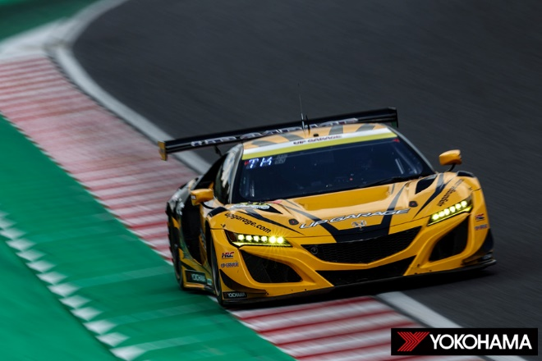
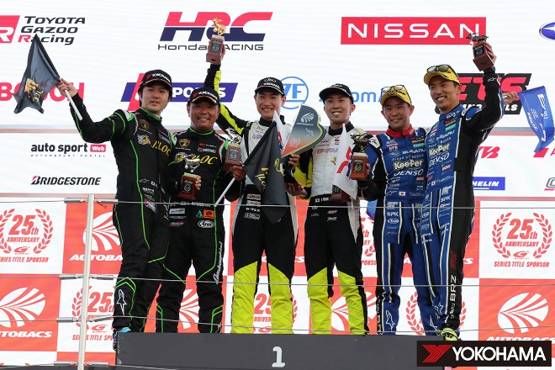
UPGARAGE NSX GT3, winner in the GT300 class
Bamboo Airways Lamborghini GT3, second place in the GT300 class
Winners Takashi Kobayashi (left center) and Syun Koide (right center), runners-up Kosuke Matsuura (second from the left) and Natsu Sakaguchi (left edge)

