20th April 2022

Cars running on YOKOHAMA’s global flagship ADVAN brand tyres finish one-two in GT300 class at 2022 SUPER GT’s opening round

YOKOHAMA is pleased to announce that cars running on its global flagship ADVAN brand tyres finished first and second in the GT300 class at the opening round of the 2022 AUTOBACS SUPER GT series, Japan’s ultimate touring car racing series. The opening round took place under clear skies on 16th – 17th April at the Okayama International Circuit in Okayama Prefecture.

KONDO RACING’s REALIZE NISSAN MECHANIC CHALLENGE GT-R (Kiyoto Fujinami/Joao Paulo de Oliveira) finished first, followed by TEAM UPGARAGE’s UPGARAGE NSX GT3 (Takashi Kobayashi/Kakunoshin Ohta). Starting in the No. 5 position, Fujinami moved his REALIZE NISSAN MECHANIC CHALLENGE GT-R into the lead in the race’s early stages before passing the baton to Oliveira. The REALIZE NISSAN MECHANIC CHALLENGE GT-R held the lead over the rest of the race and took the checkered-flag to win Round 1 for the second year in a row, a great start to its challenge to recapture the series championship it won in 2020. Meanwhile, the UPGARAGE NSX GT3, starting in the No. 4 position, moved up to third place with Kobayashi at the wheel until the first pit stop. Thereafter, rookie driver Ohta raced stably over a rather long stint to capture second place and the team’s first podium finish since Round 3 in 2020.

Under YOKOHAMA’s three-year (2021–2023) medium-term management plan, Yokohama Transformation 2023 (YX2023), the consumer tyre business aims to maximize the sales ratios of high-value-added YOKOHAMA tyres, namely the global flagship ADVAN brand, the GEOLANDAR brand of tyres for SUVs and pick-up trucks, and various winter tyres. YX2023 also positions participation in motorsports activities as crucial to the company’s effort to develop new tyre technologies that will further strengthen the ADVAN and GEOLANDAR brands. YOKOHAMA therefore is again participating in a wide variety of motorsports events in Japan and around the globe, from top-category to grassroots events. In this year’s SUPER GT series, YOKOHAMA is supplying its tyres to 15 teams competing in the GT300 class and two teams racing in the GT500 class.

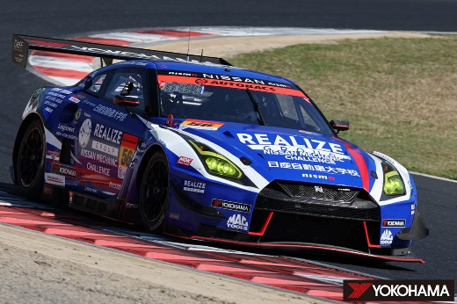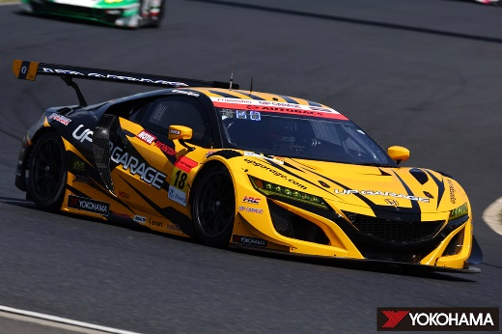
REALIZE NISSAN MECHANIC CHALLENGE GT-R UPGARAGE NSX GT3 on its way to 2nd place
racing to victory in GT300 class in GT300 class
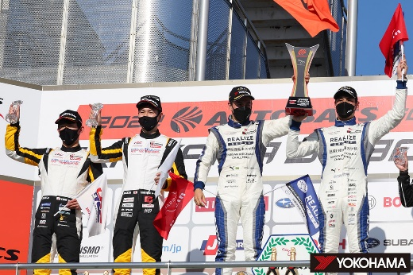On the podium (from left), Kakunoshin Ohta & Takashi Kobayashi (2nd place) and winners Joao Paulo de Oliveira & Kiyoto Fujinami

