9th May 2023

Car running on YOKOHAMA’s global flagship ADVAN brand tyres finishes first in GT300 class at SUPER GT’s second round

YOKOHAMA is pleased to announce that a car fitted with its global flagship ADVAN brand tyres raced to victory after starting in the pole position in the GT300 class in Round 2 of the 2023 AUTOBACS SUPER GT Series, Japan’s ultimate touring car racing series. The win is the second straight for an ADVAN-equipped car in the GT300 class of this year’s SUPER GT Series. The ADVAN tyres’ high performance supported the winning team as it raced to victory and keeps ADVAN on pace for achieving the back-to-back GT300 class championship that YOKOHAMA is aiming for as part of this year’s ADVAN CHALLENGE, which seeks to maximize sales of ADVAN tyres during the brand’s 45th year. Round 2 was held at Fuji Speedway in Shizuoka Prefecture on 3rd – 4th May.

The winning car was KONDO RACING’s REALIZE NISSAN MECHANIC CHALLENGE GT-R, which captured the 2022 GT300 class series championship while running on ADVAN tyres. This year’s drivers are Joao Paulo de Oliveira and Teppei Natori. Round 2 was a 450km race with a mandatory minimum of two pit stops. The REALIZE NISSAN MECHANIC CHALLENGE GT-R started the race in the pole position after winning the qualifying race on May 3. Joao Paulo de Oliveira took the wheel at the start and held onto the lead in the early stages. When he made his second pit stop during lap 61 and Teppei Natori took the wheel for the final stint, the team effectively was in second place, having been overtaken by a car that adopted an early pit-stop strategy. Natori amazingly closed the more than five-second gap he inherited to about one second around lap 70 and then retook the lead on lap 81. Natori held on to that lead in a fierce battle, finishing the race with a narrow lead of 0.579 seconds to complete the team’s win from the pole position.

Under YOKOHAMA’s three-year (2021–2023) medium-term management plan, Yokohama Transformation 2023 (YX2023), the consumer tyre business aims to maximize the sales ratios of high-value-added YOKOHAMA tyres, namely the global flagship ADVAN brand, the GEOLANDAR brand of tyres for SUVs and pick-up trucks, and various winter tyres. YX2023 also positions participation in motorsports activities as crucial to the company’s effort to develop new tyre technologies that will further strengthen the ADVAN and GEOLANDAR brands. YOKOHAMA therefore is again participating in a wide variety of motorsports events in Japan and around the globe, from top-category to grassroots events.

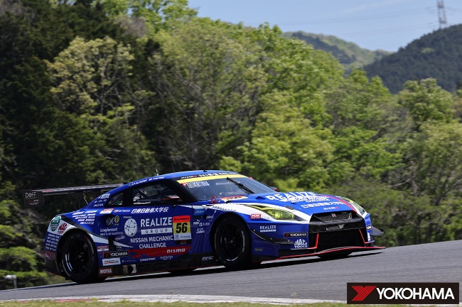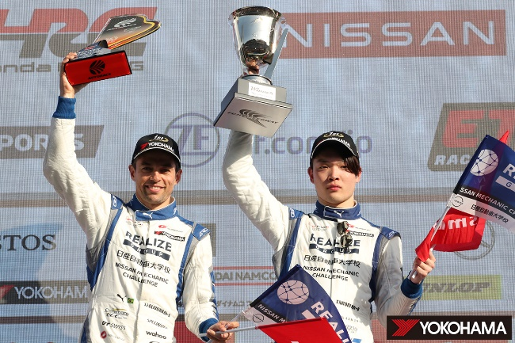
Winning drivers Joao Paulo de Oliveira (L) and Teppei Natori
GT300 class winner REALIZE NISSAN MECHANIC CHALLENGE

