20th April 2023

Car running on YOKOHAMA’s global flagship ADVAN brand tyres finishes first in GT300 class at SUPER GT’s opening round

YOKOHAMA is pleased to announce that a car fitted with its global flagship ADVAN brand tyres finished first in the GT300 class in Round 1 of the 2023 AUTOBACS SUPER GT Series, Japan’s ultimate touring car racing series. Round 1 was held over the 15th – 16th April weekend at the Okayama International Circuit in Okayama Prefecture. The Round 1 victory is an auspicious start toward a back-to-back series championship in the GT300 class, which YOKOHAMA is aiming for as part of this year’s ADVAN CHALLENGE that seeks to maximize sales of ADVAN tyres during the brand’s 45th year.

Under constantly changing weather conditions, TEAM UPGARAGE’s UPGARAGE NSX GT3 (Takashi Kobayashi/Syun Koide) raced to victory after finishing 18th in the qualifying race. Syun Koide took the driver’s seat at the start of the race on a dry track and then gradually moved toward the head of the pack after a pit stop to change to wet-use tyres when rain began falling in the first half. As the rain let up and the track surface began to dry, the UPGARAGE NSX GT3 made its second pit stop and quickly changed to slick tyres for use on the now damp track. Takashi Kobayashi replaced Koide and guided UPGARAGE NSX GT3 into the lead. Despite needing to make a third pit stop, he held on to that lead and was ahead of the pack when heavy rain forced a third red flag and ended the race. The victory was TEAM UPGARAGE’s first in five years, since 2018. Another car running on YOKOHAMA tyres, the HACHI-ICHI GR Supra GT (Kimiya Sato/Atsushi Miyake), finished third, putting two YOKOHAMA-supported teams on the podium.

Under YOKOHAMA’s three-year (2021–2023) medium-term management plan, Yokohama Transformation 2023 (YX2023), the consumer tyre business aims to maximize the sales ratios of high-value-added YOKOHAMA tyres, namely the global flagship ADVAN brand, the GEOLANDAR brand of tyres for SUVs and pick-up trucks, and various winter tyres. YX2023 also positions participation in motorsports activities as crucial to the company’s effort to develop new tyre technologies that will further strengthen the ADVAN and GEOLANDAR brands. YOKOHAMA therefore is again participating in a wide variety of motorsports events in Japan and around the globe, from top-category to grassroots events.

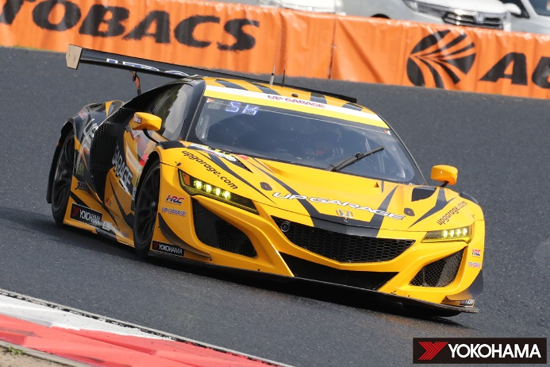
GT300 class winner UPGARAGE NSX GT3
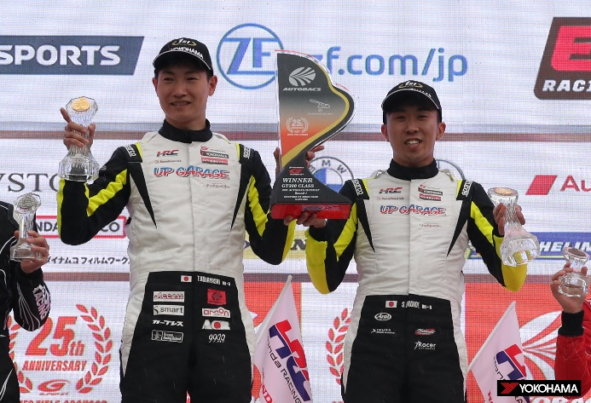
Winning drivers Takashi Kobayashi (L) & Syun Koide

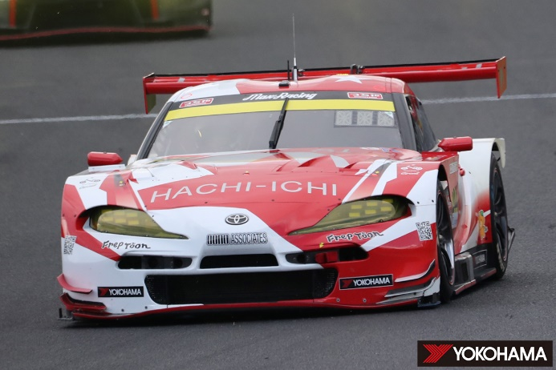
GT300 class 3rd place HACHI-ICHI GR Supra GT

