22nd October 2012

FIA WTCC - CHAMPIONSHIP STILL OPEN AFTER SUZUKA RACES

With the FIA World Touring Car Championship in its final rounds, pending only the Shanghai and Macau races, everything is still open at the very top for the Championship and the YOKOHAMA Trophy.

All three Chevrolet drivers are in contention for the coveted World Championship with an intense duel at the top, with current Champion Yvan Muller and Rob Huff tied on 345 points. Former champion Alain Menu is third with 307 points and still with options for the Championship after his triumph at Japan’s emblematic Suzuka race track last weekend. The shorter circuit used at Suzuka, though not favouring overtaking, left some memorable moments of motorsport racing with Menu’s start to finish win on race one. This was later followed with a similar feat by Stefano D’Aste who managed his second win of the season, defending his lead throughout the race hotly pursued by Pepe Oriola and Gabriele Tarquini. Minutes after crossing the finish line, an excited D’Aste commented how technical the track was and paid tribute to his team for the great set up of the car.

For his part the Italian veteran Tarquini who is currently fourth in the general standings with 220 points explained he had tried everything he could to overtake but the narrow track on the one hand and the good driving of those in front did not enable him to do any more.

With the manufacturers’ championship going to Chevrolet, Seat was also celebrating a podium finish for their drivers on race two. Honda, also on their first experience at WTCC currently taking part in the Asian races to fully join next season, picked up their first points to the delight of their team and to make history of a newcomer manufacturer obtaining some success on their debut.

Meanwhile the challenge for the YOKOHAMA Trophy has also heated up with Norbert Michelisz (136 points), current leader of the trophy seeing his lead reduced to only ten points from Oriola (126 points) and followed by D’Aste (101 points).

November 4th sees rounds 21 and 22 at Shanghai.

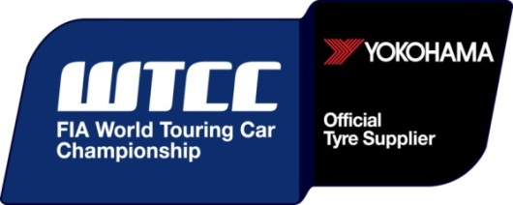

Notes to Editors
YOKOHAMA is one of the leading Tyre manufacturers in the world and is Official Tyre supplier for;
FIA World Touring Car Championship (WTCC) – since 2006
European Touring Car Cup (ETCC) – since 2005
Intercontinental Rally Challenge (IRC) – since 2007
Scandinavian Touring Car Championship (STCC) – since 2010
Russian Touring Car Championship (RTCC) – since 2006
Chinese Touring Car Championship (CTCC) – since 2010
Irish Touring Car Championship (ITCC) – new for 2012
International Formula 3 Grand Prix Macau – since 1983
ATS German Formula 3 – until 2005 and since 2007
FIA F2 Championship – new for 2012
Japanese Formula 3 – since 2011
ADAC GT Masters – new for 2012
GT Asia – new for 2012

