24th April 2024
YOKOHAMA supplying ADVAN racing tyres for Abu Dhabi Autonomous Racing League’s autonomous car race in the UAE
YOKOHAMA announces that it is supplying ADVAN racing tyres to the Abu Dhabi Autonomous Racing League (hereafter, A2RL) for its inaugural autonomous car race to be held on 27th April 2024, in the United Arab Emirates (UAE). The A2RL is launching a driverless racing series that will use the SF23 formula racing car used in the Japanese SUPER FORMULA Championship series (hereinafter, SUPER FORMULA), Asia’s ultimate formula racing series.
The A2RL race is being organized by ASPIRE, the technology program management and business development arm of the UAE’s Advanced Technology Research Council, with the aim of expanding the possibilities of future mobility. The A2RL is being supported by Japan Race Promotion Inc. (hereafter, JRP), the SUPER FORMULA organizer, which is supplying racing cars based on the SF23 used in SUPER FORMULA races in Japan and equipped with software developed by ASPIRE. The A2RL race will be a competition among cars with different autonomous driving software and algorithms developed by eight participating teams of software programmers and engineers. The participating teams from Asia, North America, and Europe will be competing for a $2.25 million in first-place prize money.
Through JRP, YOKOHAMA will support ASPIRE’s A2RL racing series by providing the same ADVAN A005 racing tyres currently being used as the control tyres for SUPER FORMULA races in Japan. The ADVAN A005 has achieved a 33%^{*1} sustainable material content ratio while maintaining the same outstanding grip performance as previously used tyres.
*1: The 33% sustainable materials content ratio includes natural rubber and various naturally derived compounding agents including oil produced from oil palm nuts and orange peels, as well as recycled iron, rubber recycled from waste tyres, and synthetic rubber produced using the mass balance method^{*2}.
*2: A method that allows you to label a commercial product as a biomass-derived product based on the volume of biomass-derived raw materials used during the process of turning raw materials into final products and the distribution process. Commercial products labelled as biomass-derived raw products therefore are regarded as fully biomass-derived regardless of their actual volume of biomass-derived materials.
The consumer tyre strategy in YOKOHAMA’s new three-year (2024–2026) medium-term management plan, Yokohama Transformation 2026 (YX2026), aims to maximize the sales ratios of high-value-added tyres by expanding sales of YOKOHAMA’s global flagship ADVAN brand, the GEOLANDAR brand of tyres for SUVs and pick-up trucks, winter tyres, and 18-inch and larger tyres. YOKOHAMA positions participation in motorsports activities as crucial to its effort to further strengthen the ADVAN and GEOLANDAR brands. YOKOHAMA therefore is again participating in a wide variety of motorsports events around the globe, from top-category to grassroots events.

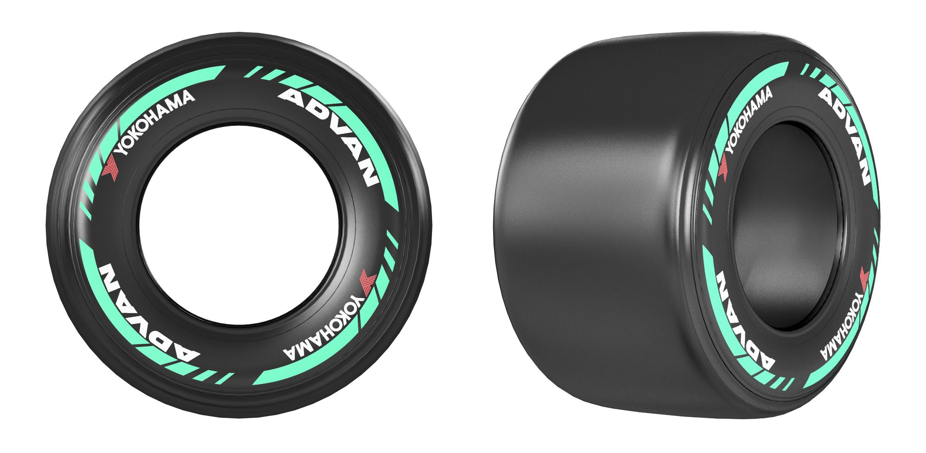
ADVAN racing tyre made from sustainable materials and used in dry conditions

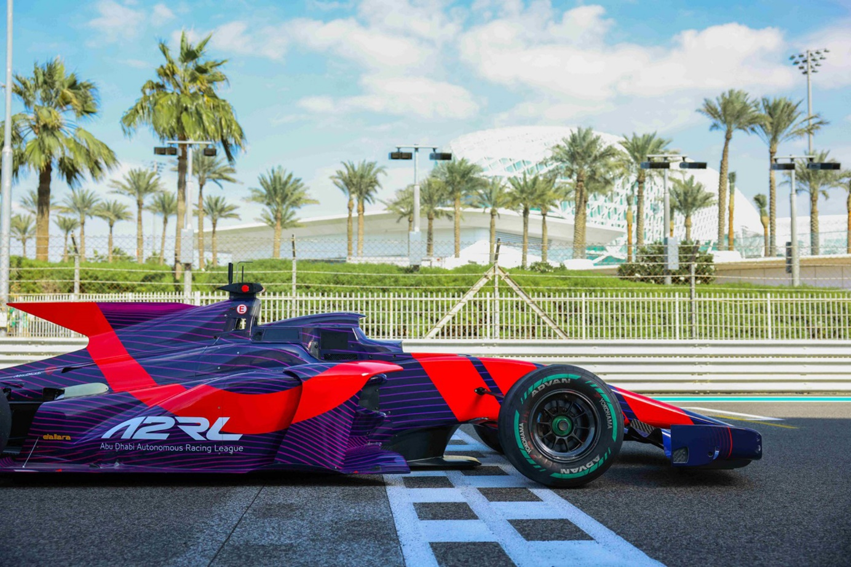
A self-driving SF23 race car

