2nd April 2024

YOKOHAMA supplying ADVAN Sport V105 tyres coming factory-equipped on Subaru’s new Impreza

YOKOHAMA announced today that it has begun delivering tyres to Subaru Corporation for use as original equipment (OE) on the car manufacturer’s new Impreza. The new Impreza cars to be sold in Europe and the Latin America will be fitted with ADVAN Sport V105 tyres (size 225/40R18 92W).*
*ADVAN Sport V105 will not be equipped on Impreza cars sold in Japan.

The ADVAN Sport V105 is an ultra-high performance tyre under the ADVAN brand, YOKOHAMA’s global flagship tyre brand. The tyre delivers excellent driving performance combined with superior comfort and safety characteristics.
The ADVAN Sport V105 tyres being supplied as OE on the new Impreza feature a specially tuned structure that enhances the car’s handling stability and ride comfort while also reducing rolling resistance. In addition, non-penetrating sipes have been applied in some of the tyre’s lug grooves to reduce passing noise outside the vehicle.

The Impreza is a standard model in the Subaru lineup that provides drivers with superior safety and dynamic sensation unusual for a car in its class. Past Impreza models are known for their sporty yet casual design, excellent driving performance that delivers an enjoyable driving experience, advanced safety equipment that provide peace of mind, and a range of utility features that both the driver and passengers can fully enjoy. While inheriting these features of past models, the all-new Impreza has been enhanced by the inclusion of many of Subaru’s latest and most advanced technologies, significantly enhancing the car’s safety performance and dynamic driving sensation.*
*Abridged translation of Subaru’s January 13, 2023, news release “Subaru unveils the all-new Impreza (Japanese specifications prototype)”
(https://www.subaru.co.jp/news/2023_01_13_170612/）

Under YOKOHAMA’s three-year (2024–2026) medium-term management plan, Yokohama Transformation 2026 (YX2026), the consumer tyre business aims to maximize the sales ratios of high-value-added tyres. One of the key initiatives under this strategy is promoting the global flagship ADVAN brand tyres and the GEOLANDAR brand tyres for SUVs and pick-up trucks as original equipment for new cars.
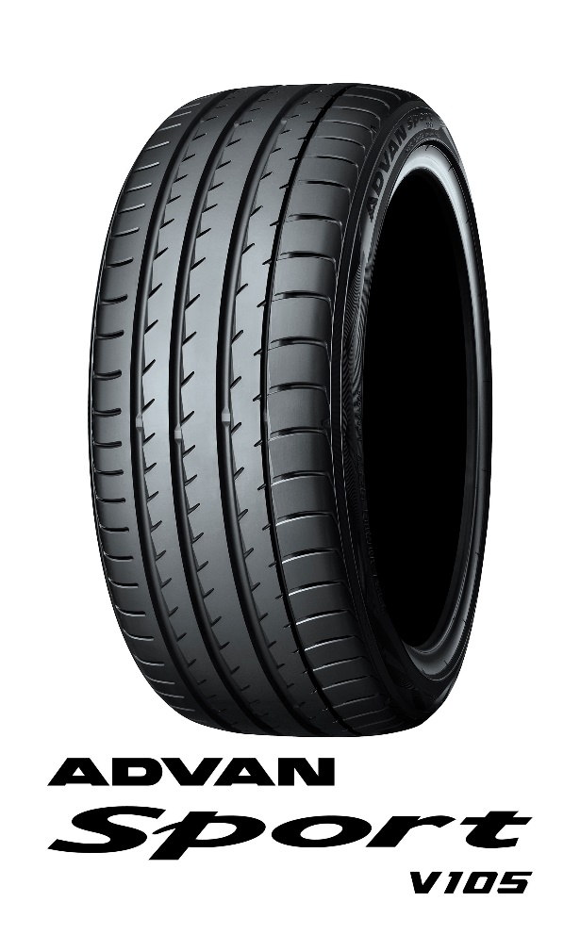
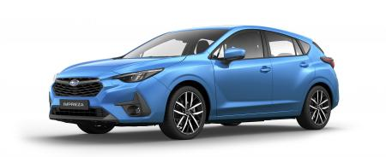

The new Impreza *The above photo is used with the permission of Subaru Corporation. Reprint or other usage of this image without prior permission from Subaru Corporation is strictly prohibited.

